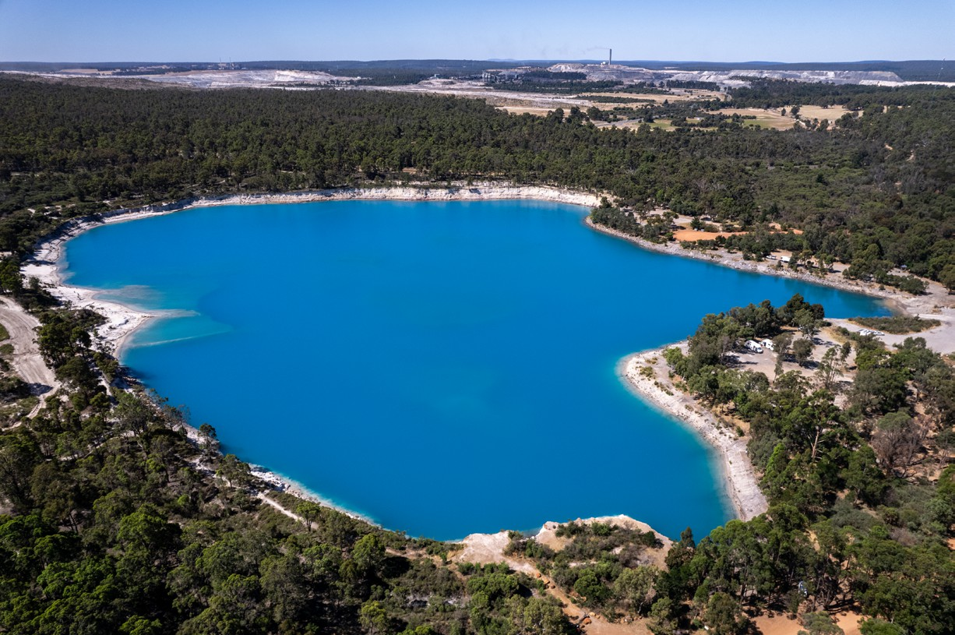

Regional Profiles

**Collie**

**Total Area:** 1,710 sq. km **Population:** 8,812 **Working Zones:** Collie *(maps at end of profile)*

# Region Selection Rationale

|  |  |
| --- | --- |
| **Exposure to decarbonisation** | **Potential to harness economic opportunities from decarbonisation** |
| * **Carbon intensity:** 3 coal-fired power stations and 2 safeguards. As of 2023-24, safeguards in the region account for 7% of WA safeguard scope 1 emissions; region has large amounts of employment in coal power generation, related coal mining and a large alumina refinery. * **Urgency:** High – two power stations are expected to close by 2030. * **Adaptive capacity:** Very low, high unemployment (5.6% as of Dec 2024) and working age population decline. * **Readiness:** High – there is already strong planning, funding and preparation for decarbonisation, including establishment of a working group for transition and a supported just transition framework, with announced WA government funding of $662 million. This includes the   $200 million Collie Industrial Transition Fund to attract major projects. | * **Natural capital:** Moderate wind and solar capacity and potential for green manufacturing (e.g. proposed green steel mill and net zero magnesium refinery). * **Workforce compatibility:** High proportion of workers in the region are in jobs highly compatible with clean energy industries. * **Enabling infrastructure:** Connected by major highways and approximately 50km from Bunbury Port, which has road and rail links, supporting connectivity, logistics and trade. No commercial airport. |

# Carbon-Intensive Facilities

## Coal Fired Power Stations (CFPS)

|  |  |  |  |  |  |  |  |
| --- | --- | --- | --- | --- | --- | --- | --- |
| **Name** |  | **Owner** | **Public closure date** | **Supplying Coal Mine** | **Scope 1 emissions (tCO2-e) (23/24)** | **% of Scope 1 WA emissions (23/24)** | **% of Scope 1 Aus emissions (23/24)** |
| Bluewaters Power Station | | Kansai Electric & Sumitomo | Not reported | Ewington | 2,590,563 | 4% | 1% |
| Collie Power Station |  | Synergy (WA gov) | 2027 | Ewington & Premier | 920,053 | 1% | 0.3% |
| Muja Power Station C & D | | Synergy (WA gov) | 2025 (C) &  2029 (D) | Ewington & Premier | 3,091,936 | 4% | 1% |
| Total | 3 | 3 |  | 2 | 6,602,552[1] | 10%[2] | 2% |

## Metal Manufacturing / Refineries and Smelters

|  |  |  |  |  |  |  |
| --- | --- | --- | --- | --- | --- | --- |
| **Name** | **Owner** | **PPA expiry date** | **Power source** | **Scope 1 emissions (tCO2-e) (23/24)** | **% of Scope 1 WA emissions (23/24)** | **% of Scope 1 Aus emissions (23/24)** |
| WOR01  (Worsley Alumina) | South32 Worsley Alumina Pty Ltd | np | Worsley Refinery Power Station | 3,177,815 | 5% | 1% |

## Coal mines

|  |  |
| --- | --- |
| **Name** | **Safeguard** |
| Premier | 1 |
| Ewington | 0 |
| Total | 1 |

## Safeguard Facilities (Emit 100,000+ tonnes CO2 annually - power stations connected to grid are exempt)

|  |  |  |  |  |
| --- | --- | --- | --- | --- |
| **Type** | **No.** | **Total scope 1 emissions (tCO2-e) (23/24)** | **% of WA scope 1 safeguard emissions (23/24)** | **% of Aus scope 1 safeguard emissions (23/24)** |
| Manufacturing (Worsley Alumina) | 1 | 3,177,815 | 6.7% | 2.5% |
| Coal mines (Premier) | 1 | 110,291 | 0.2% | 0.1% |
| Total safeguards | 2 | 3,288,106 | 6.9% | 2.6% |

# Major Industries

## Gross Regional Product (GRP): $2.7 billion (0.6% of Gross State Product)[3]

|  |  |  |
| --- | --- | --- |
| **Ranked Industries With Most Value** | **Value** | **% of GRP** |
| Mining | $1,755 m | 64% |
| Manufacturing | $269 m | 10% |
| Electricity, Gas, Water & Waste Services | $256 m | 9% |
| Rental, Hiring & Real Estate Services | $113 m | 4% |
| Construction | $88 m | 3% |

|  |  |  |  |
| --- | --- | --- | --- |
| **Ranked Employing Industries (by usual residence[4])** | **No. of employees (% of workforce)** | **Ranked Employing Industries (by place of work[5])** | **No. of employees (% of workforce)** |
| Total labour force living in region | 3,422[6] | Total labour force working in region | 4,774[7] |
| Mining | 608 (18%) | Manufacturing | 1,138 (25%) |
| Health Care and Social Assistance | 352 (11%) | Mining | 756 (16%) |
| Retail & Wholesale Trade | 331 (10%) | Electricity, Gas, Water & Waste Services | 523 (11%) |
| Education and Training | 283 (9%) | Health Care and Social Assistance | 339 (7%) |
| Accommodation and Food Services | 266 (8%) | Education and Training | 311 (7%) |

# Major Investments

## Major clean energy and heavy industry projects (excluding cancelled and completed) (top projects by value)

|  |  |  |  |  |
| --- | --- | --- | --- | --- |
| **Project** | **Description** | **Category** | **Status** | **Value** |
| **Collie Battery** | Neoen’s (French producer of renewable energy) first 4-hour long duration battery and its first major project in WA. Project has development approval for 1 GW / 4 GWh.  Stage 1 is sized at 219 MW / 877 MWh Stage 2 is sized at 341 MW / 1,363 MWh  Once fully operational, Collie Battery will provide short duration storage in peak times to ease pressure on the grid. It will have the ability to charge and discharge 20% of the average demand in WA’s SWIS. | Battery | Construction on stage 2 began  in May 2024 | $2,000 m |
| **Greenbushes Expansion CGP3** | Construction of a third chemical grade processing plant (CGP3) at the existing lithium facility. | Key mineral | Announced | $880 m |
| **Collie Green Steel Mill** | Mill will use an electric arc furnace powered by renewable energy to convert Western Australian scrap steel into rebar used in construction. | Green manufacturing | Announced | $400 m |
| **Collie BAM Facility** | Produce high-grade anode materials for lithium- ion battery. | Manufacturing | Announced | $341 m |
| **Collie Net Zero Magnesium Refinery** | Project will establish and construct a pilot plant to produce high-purity magnesium metal in Collie’s Light Industrial Area. | Manufacturing | Announced | $18 m |

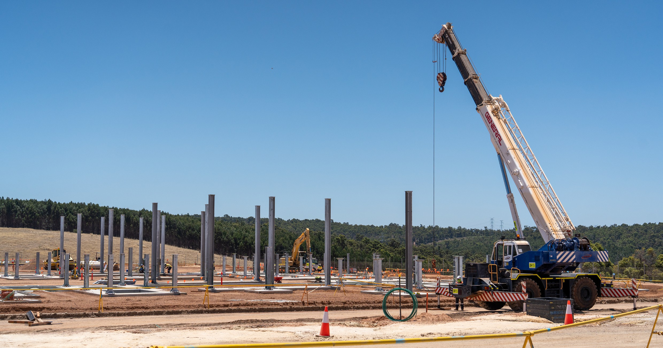

# Transmission Infrastructure Projects

## SWIS (South West Interconnected Grid System) Transmission Planning Update

|  |  |  |  |  |
| --- | --- | --- | --- | --- |
| **Name** | **Description** | **Status** | **Timing** | **Costs** |
| **Clean Energy Link**  **- East** | Clean Energy Link (both East and South connections) aims to optimise the existing infrastructure and prepare the regional electricity network in WA for clean energy future.  Focuses on expanding the State’s main electricity network to enable more renewable energy connections and supporting industry growth and electrification of processes to aid transitioning to net zero emissions by 2050. | In Planning Stage | N/A | $21 m |
| **Clean Energy Link - South** | In Planning Stage | N/A | N/A |

# Employment

|  |  |  |
| --- | --- | --- |
| **Indicator (2021 Census unless otherwise stated)** | **Collie** | **WA** |
| Average working age | 42 | 38 |
| Median income (annual gross, exc. super) | $26.0K - $33.8K | $41.6K - $52.0K |
| Participation in workforce | 51% | 64% |
| Female participation in workforce | 48% | 60% |
| Unemployment rate (Dec 2024) | 5.6% | 3.4% |
| Regional Labour Market Index (Dec 2024) | N/A[8] | N/A |

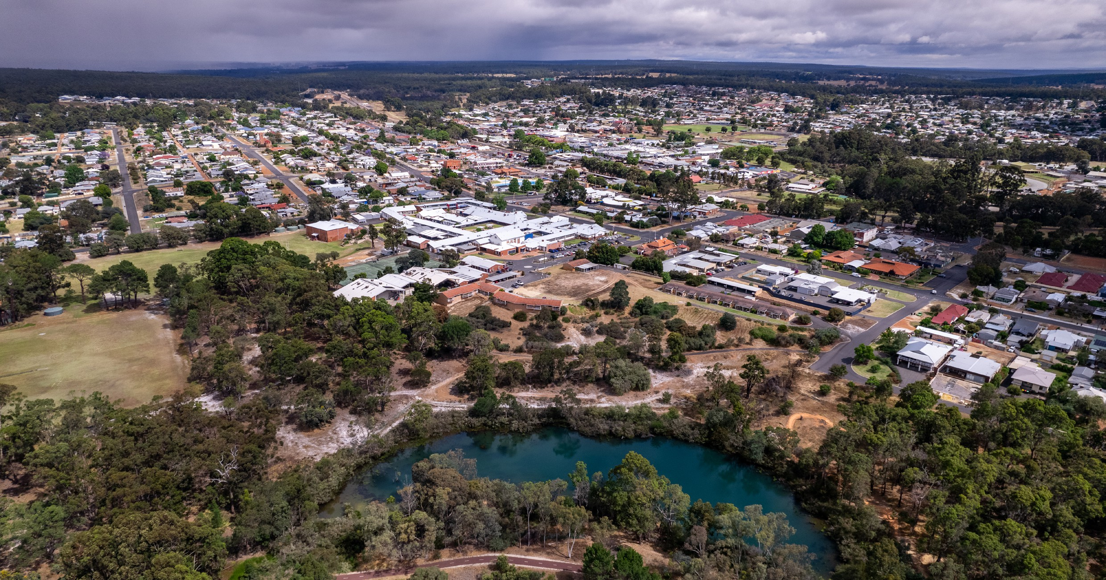

# Demographics

|  |  |  |
| --- | --- | --- |
| **Indicator (2021 Census)** | **Collie** | **WA** |
| Median age | 44 | 37 |
| First Nations (% of population) | 4% | 3% |
| Population growth (2016-2021) | 0.2% | 8% |
| Educational attainment (% of population aged 15 & above):[9] | 68% | 40% |
| * Below Y12 |
| * Y12 or equivalent | 32% | 60% |
| * Cert III & IV | 29% | 19% |
| * Bachelor and above | 7% | 26% |

# Housing

|  |  |  |
| --- | --- | --- |
| **Indicator (2021 Census unless otherwise stated)** | **Collie** | **WA** |
| Homelessness[10] | 0.4% | 0.4% |
| Commonwealth Rent Assistance (Dec 2024)[11] | 5% | 4% |
| Mortgage stress[12] | 9% | 13% |
| Rental stress[13] | 33% | 28% |

# Map highlights location of operating coal mines, coal fired power stations and gas fired power stations in CollieMap of Region – Power Stations and Mines

# Map highlights location of safeguard facilities in CollieMap of Region – Safeguards

Net Zero Economy Authority | Collie Regional Profile | June 2025 7

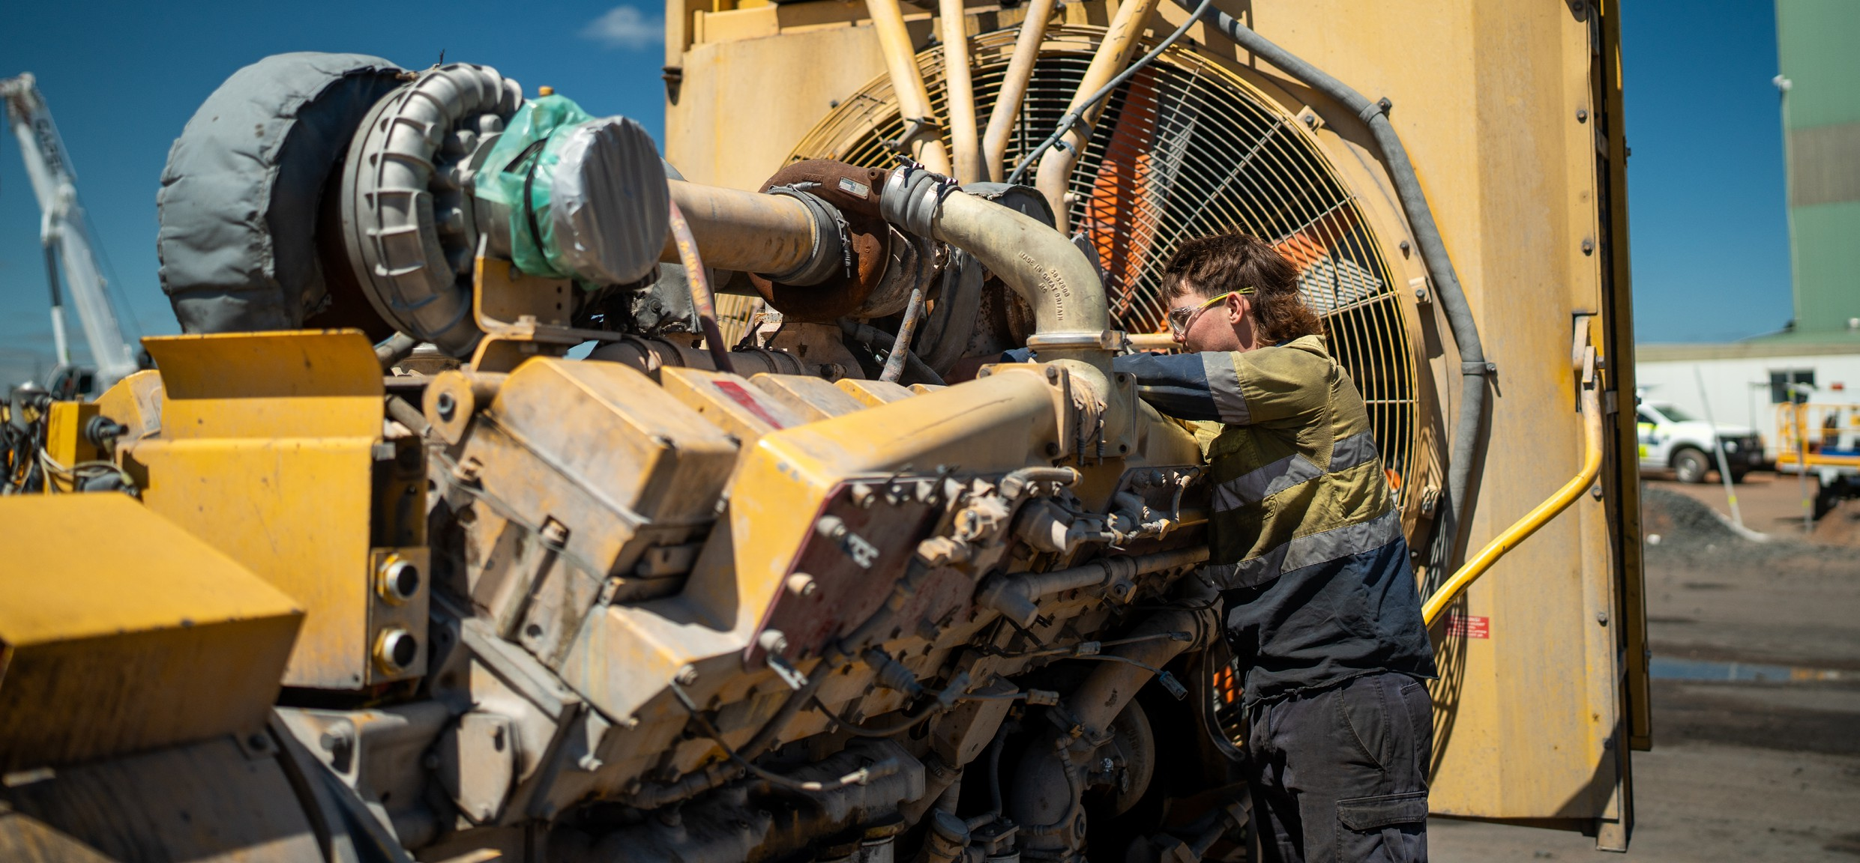

# Data Sources

|  |  |  |
| --- | --- | --- |
| **Section** | **Source** | **Date** |
| **Overview** |  |  |
| Total Population | [Census](https://www.abs.gov.au/statistics/microdata-tablebuilder/tablebuilder), ABS | 2021 |
| Area | [Mesh Blocks - SA2 Allocation Files](https://www.abs.gov.au/statistics/standards/australian-statistical-geography-standard-asgs-edition-3/jul2021-jun2026/access-and-downloads/allocation-files), ABS | 2021 |
| **Priority Region Selection Rationale** |  |  |
| All | [Regional identification framework](https://www.netzero.gov.au/sites/default/files/documents/2025-03/NZEA_Regional_Framework%20%281%29.pdf) | Feb 2025 |
| Emissions | [Safeguard facilities data](https://cer.gov.au/markets/reports-and-data/safeguard-data/2023-24-baselines-and-emissions-data), CER | 2023-24 |
| **Carbon Intensive Industries** |  |  |
| Coal Fired Power Stations | [Greenhouse and energy information by designated](https://cer.gov.au/markets/reports-and-data/nger-reporting-data-and-registers/2023-24-published-data-highlights) [generation facility,](https://cer.gov.au/markets/reports-and-data/nger-reporting-data-and-registers/2023-24-published-data-highlights) CER  [Greenhouse and energy information - published data](https://cer.gov.au/markets/reports-and-data/nger-reporting-data-and-registers/2022-23-published-data-highlights#available-data) [highlights](https://cer.gov.au/markets/reports-and-data/nger-reporting-data-and-registers/2022-23-published-data-highlights#available-data) (WA) | 2023-2024 |
| Coal mines | [Safeguard facilities data](https://cer.gov.au/markets/reports-and-data/safeguard-data/2023-24-baselines-and-emissions-data), CER | 2023-24 |
| Power station closure dates | [Collie Community Fact Sheet](https://www.wa.gov.au/system/files/2023-08/colliecommunityfactsheet.pdf), WA Government | August 2023 |
| Safeguard facilities | [Safeguard facilities data](https://cer.gov.au/markets/reports-and-data/safeguard-data/2023-24-baselines-and-emissions-data), CER | 2023-2024 |
| **Major Industries** |  |  |
| Ranked Industries by most value | [Economic data](https://www.remplan.com.au/)[14]a, REMPLAN | 2025 |
| Ranked Employing Industries | [Census](https://www.abs.gov.au/statistics/microdata-tablebuilder/tablebuilder), ABS | 2021 |
| **Major Investments** |  |  |
| All | [Funded projects](https://arena.gov.au/projects/?project-value-start=0&project-value-end=200000000), ARENA [HyResource](https://research.csiro.au/hyresource/projects/projects-spreadsheet/)[15]b, CSIRO  [Resources and Energy Major Projects](https://www.industry.gov.au/publications/resources-and-energy-major-projects-2024), DISR | 2025  2025  2024 |

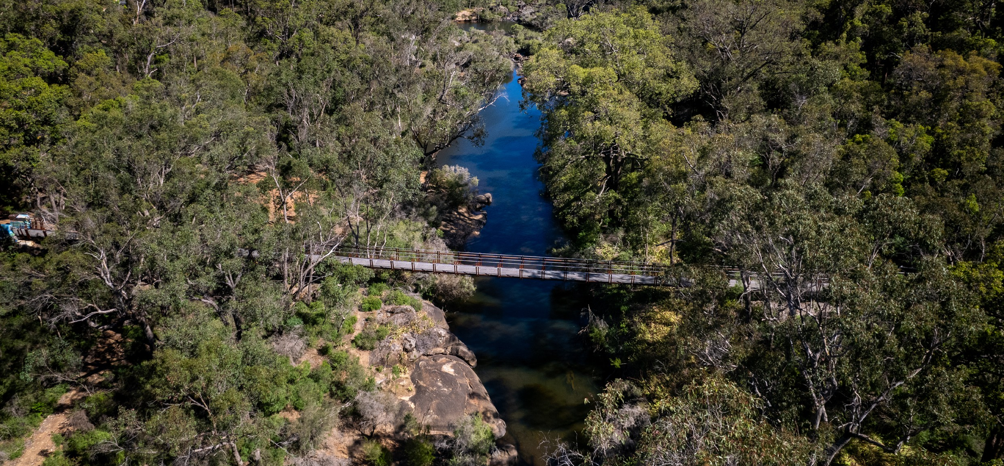

|  |  |  |
| --- | --- | --- |
| **Section** | **Source** | **Date** |
| **Transmission Infrastructure Projects** |  |  |
| All | [Integrated System Plan](https://aemo.com.au/en/energy-systems/major-publications/integrated-system-plan-isp/2024-integrated-system-plan-isp)[16]c, AEMO | June 2024 |
| **Employment** |  |  |
| Average working age, median income, labour force participation | [Census](https://www.abs.gov.au/statistics/microdata-tablebuilder/tablebuilder), ABS | 2021 |
| Regional Labour Market Index | [Regional Labour Market Indicator, Jobs and Skills Australia](https://www.jobsandskills.gov.au/sites/default/files/2025-02/regional_labour_market_indicator_results_-_december_2024.pdf) | December 2024 |
| Unemployment rate: |  |  |
| * Collie * WA | [Small Area Labour Markets](https://www.dewr.gov.au/employment-research/small-area-labour-markets#downloads), Jobs & Skills Australia [Labour Force, Australia,](https://www.abs.gov.au/statistics/labour/employment-and-unemployment/labour-force-australia/dec-2024) ABS | December 2024  December 2024 |
| **Demographics** |  |  |
| All | [Census](https://www.abs.gov.au/statistics/microdata-tablebuilder/tablebuilder), ABS | 2021 |
| **Housing** |  |  |
| Homelessness, mortgage stress, rental stress | [Census](https://www.abs.gov.au/statistics/microdata-tablebuilder/tablebuilder), ABS | 2021 |
| Commonwealth Rental Assistance | [Benefit and Payment Recipient Demographics - quarterly](https://data.gov.au/data/dataset/dss-payment-demographic-data/resource/38a5c0c7-5246-428b-bc0c-3d1fe153ea78) [data](https://data.gov.au/data/dataset/dss-payment-demographic-data/resource/38a5c0c7-5246-428b-bc0c-3d1fe153ea78), DSS | December 2024 |
| **Maps** |  |  |
| All | Produced using data from [Australian Bureau of Agricultural](https://data.gov.au/data/dataset/dss-payment-demographic-data/resource/38a5c0c7-5246-428b-bc0c-3d1fe153ea78) [and Resource Economics and Sciences (ABARES)](https://data.gov.au/data/dataset/dss-payment-demographic-data/resource/38a5c0c7-5246-428b-bc0c-3d1fe153ea78), DAFF | December 2023 |

Note: All datasets maintained by third party providers listed above and date reflects most recent data available.

1. Sum of emissions for individual power stations do not add up to Total due to rounding.
2. See above.
3. Data sourced using REMPLAN (incorporating ABS 2021 Census Place of Work Employment (Scaled); 2022 / 2023 National Input Output Tables; June 2024 Gross State Product figures).
4. Data by usual residence means only employees living in Collie region would be captured (regardless of whether or not they actually work in Collie region).
5. Data by place of work means only employees working in Collie region would be captured (regardless of whether or not they actually reside in Collie region).
6. Note, for purposes of calculating shares of workforce, total of 3,290 was used (total workforce minus those workers in ‘Industry of Employment’ categories listed as ‘inadequately described’ and ‘not stated’).
7. Note, for purposes of calculating shares of workforce, total of 4,596 was used (total workforce minus those workers in ‘Industry of Employment’ categories listed as ‘inadequately described’ and ‘not stated’).
8. Note, Regional Labour Market Index is calculated by SA4. Bunbury SA4, which Collie SA2 sits within, has an ‘average’ rating but its unemployment rate of 3.5% is much lower than 7.0% in Collie, meaning using Bunbury’s RLMI score as a proxy for Collie would be misleading.
9. Excludes ‘not stated’ and categories are not cumulative.
10. Share of population
11. Share of population
12. Share of households where rent payments are >30% of household income
13. Share of households where repayments are >30% of household income
14. a Access may be restricted on a secure network: https://www.remplan.com.au
15. b Access may be restricted on a secure network: https://research.csiro.au/hyresource/projects/projects-spreadsheet/
16. c Access may be restricted on a secure network: https://aemo.com.au/en/energy-systems/major-publications/integrated- system-plan-isp/2024-integrated-system-plan-isp