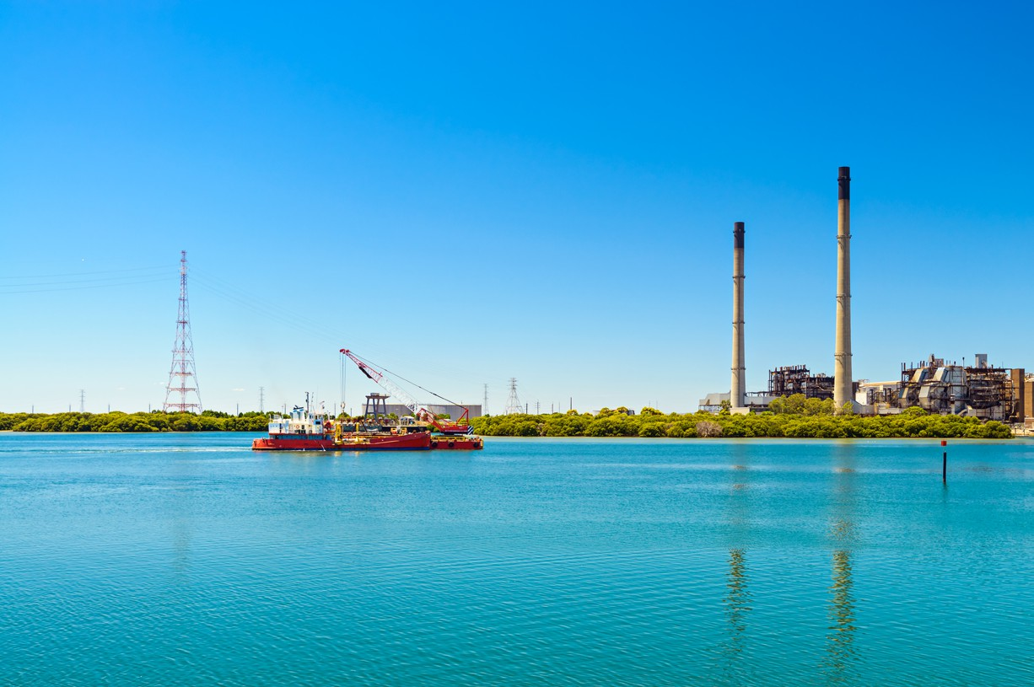

Regional Profiles

**Adelaide**

**Total Area:** 1,352 sq. km **Population:** 1,131,022 **Working Zones:** Adelaide & surrounds[1] *(maps at end of profile)*

# Region Focus Rationale

|  |
| --- |
| **Exposure to decarbonisation** |
| * **Carbon intensity:** 8 gas-fired power stations and 3 safeguards. As of 2023-24, safeguards in the region account for 20% of SA safeguard scope 1 emissions. * **Urgency:** High - Torrens Island power station is expected to close in 2026, Osborne is expected to close in 2027, and Dry Creek is expected to close in 2030. All other power stations are not expected to close until 2037 and beyond. * **Adaptive capacity:** Moderate, partly driven by relatively low unemployment (4.1% as of Dec 2024). Pockets of low adaptive capacity surrounding Torrens Island. * **Readiness:** The legislative framework for the Energy Industry Jobs Plan commenced on 11 December 2024, with the commencement of the Net Zero Economy Authority Act 2024 (the Act). In January 2025, the Authority commenced consultation to assess whether Torrens Island B power station should be included in the EIJP, in the lead-up to its scheduled closure in June 2026. These consultations are focused on understanding how workers and businesses are impacted by the closure, what support workers can already access, and what other employment opportunities exist in the region. |

# Carbon-Intensive Industries

## Gas Fired Power Stations

|  |  |  |  |  |  |
| --- | --- | --- | --- | --- | --- |
| **Name** | **Owner** | **Closure year (**[**AEMO NEM**](https://aemo.com.au/energy-systems/electricity/national-electricity-market-nem/nem-forecasting-and-planning/forecasting-and-planning-data/generation-information)  [**Gen Apr 2025**](https://aemo.com.au/energy-systems/electricity/national-electricity-market-nem/nem-forecasting-and-planning/forecasting-and-planning-data/generation-information)**[2]a)** | **Scope 1 emissions (tCO2-e) (23/24)** | **% of SA scope 1 emissions (23/24)** | **% of Aus scope 1 emissions (23/24)** |
| Barker Inlet | AGL | 2044 | 163,814 | 2% | 0.1% |
| Bolivar | Iberdrola Australia Energy Markets Pty Ltd | 2045 | 23,494 | 0.2% | 0.01% |
| Dry Creek | ENGIE | 2030 | 12,596 | 0.1% | 0.00% |
| Osborne | ATCO and Origin Energy | 2027 | 156,932 | 2% | 0.1% |
| Pelican Point | ENGIE | 2037 | 677,090 | 7% | 0.2% |
| Quarantine | Origin Energy | 2044-55 | 72,916 | 1% | 0.02% |
| Snapper Point | Nexif and RATCH | 2046 | 26,704 | 0.3% | 0.01% |
| Torrens Island | AGL | 2026 | 370,328 | 4% | 0.1% |
| Total 8 | 8 |  | 1,503,874 | 15% | 0.5% |

## Safeguard Facilities (Emit 100,000+ tonnes CO2 annually - power stations connected to grid are exempt)

|  |  |  |  |  |
| --- | --- | --- | --- | --- |
| **Type** | **No.** | **Scope 1 emissions (tCO2-e) (23/24)** | **% of SA scope 1 safeguard emissions (23/24)** | **% of AUS scope 1 safeguard emissions (23/24)** |
| Cement, lime, plaster & concrete product manufacturing (Angaston Operations & Birkenhead Operations) | 2 | 922,272 | 17% | 1.6% |
| Glass manufacturing (Orora Glass Plant Gawler) | 1 | 189,646 | 3% | 0.1% |
| Total safeguards | 3 | 1,111,918 | 20% | 1.8% |

# Major Industries

## Gross Regional Product (GRP): $97.7 billion (70.1% of SA’s Gross State Product)[3]

|  |  |  |
| --- | --- | --- |
| **Ranked Industries with most value** | **Value (m)** | **% of GRP** |
| Rental, Hiring & Real Estate Services | $12,636 | 12.9% |
| Health Care & Social Assistance | $11,289 | 11.6% |
| Public Administration & Safety | $8,821 | 9.0% |
| Financial & Insurance Services | $8,327 | 8.5% |
| Construction | $7,826 | 8.0% |

|  |  |  |  |
| --- | --- | --- | --- |
| **Ranked Employing Industries (by usual residence[4])** | **No. of employees (% of workforce)** | **Ranked Employing Industries (by place of work[5])** | **No. of employees (% of workforce)** |
| Total labour force living in region | 547,065[6] | Total labour force working in region | 567,786[7] |
| Health Care and Social Assistance | 93,374 (18%) | Health Care and Social Assistance | 100,641 (18%) |
| Retail & Wholesale Trade | 65,794 (12%) | Retail & Wholesale trade | 69,489 (13%) |
| Education & Training | 49,493 (9%) | Education & Training | 52,262 (10%) |
| Construction | 43,623 (8%) | Public Administration & Safety | 44,423 (8%) |
| Professional, Scientific & Technical Services | 40,294 (8%) | Professional, Scientific & Technical Services | 43,192 (8%) |

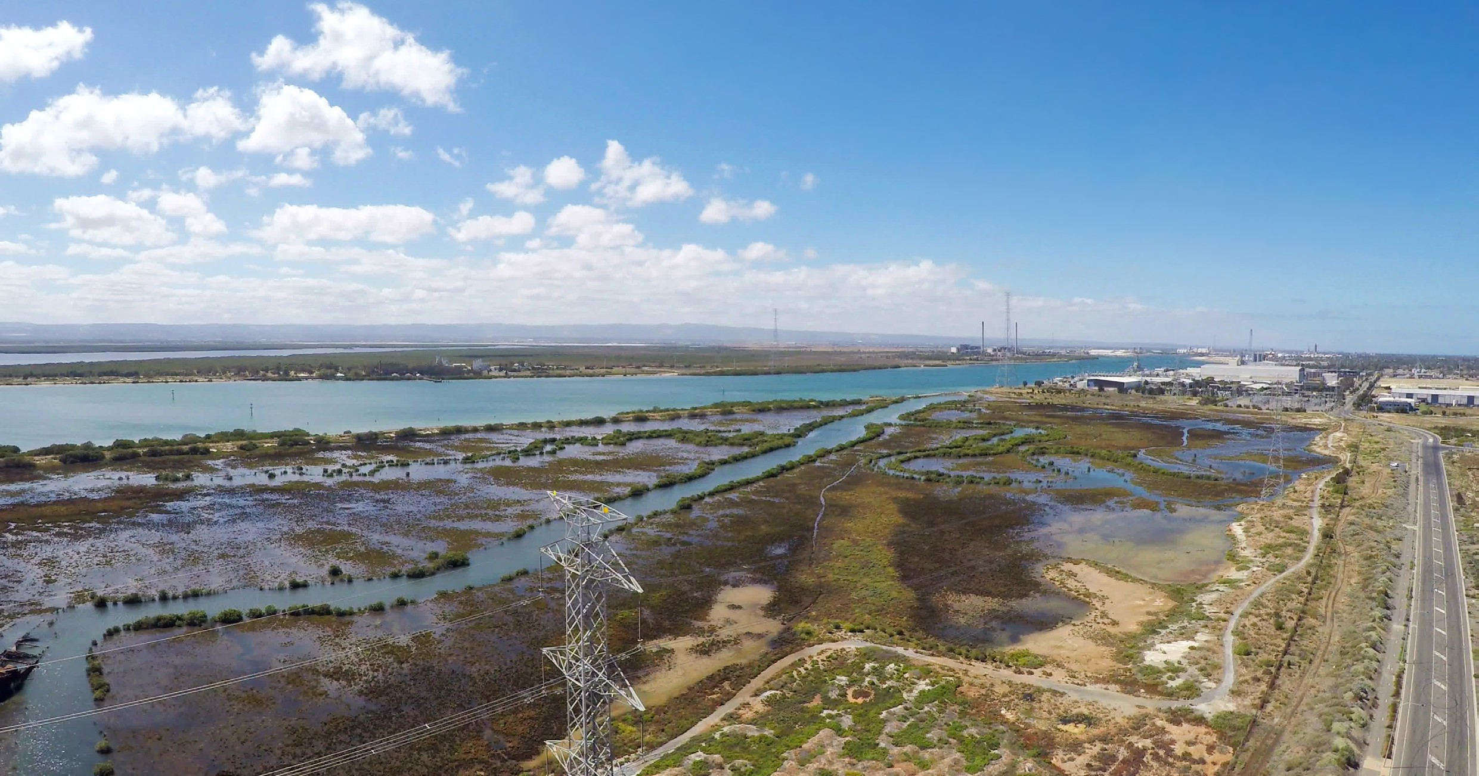

# Major Investments

## Major clean energy and heavy industry projects (excluding cancelled and completed) (top projects by value)

|  |  |  |  |  |
| --- | --- | --- | --- | --- |
| **Project** | **Description** | **Category** | **Status** | **Value** |
| Neoen Big Battery (Blyth) Deployment Project | Neoen will procure the construction of a Grid- Forming Battery with a minimum size of 200 MW / 400MWh at Blyth in South Australia. | Battery storage | Under construction | $337.5m |
| Green Hydrogen and Battery Energy Storage System | Consists of demonstrator scale hydrogen production and battery storage system located at Bolivar and provides proof of concept for the  transport of hydrogen absorbed in a metal hydride tank for safe handling and further utilisation in Indonesia. | Renewable energy | Under construction | $17.5 m |
| Hydrogen Park Adelaide | Will deliver a renewable hydrogen blend to customers on the existing gas network. | Green hydrogen | Under construction | N/A |
| HILT CRC - upgrading iron ore for DRI production using seawater | HILT CRC will lead the development of a scalable hydrometallurgical caustic leaching process to upgrade iron ore using the reagents derived from seawater reverse osmosis (RO) brines. | Research & Development | Feasibility | $5.73 m |

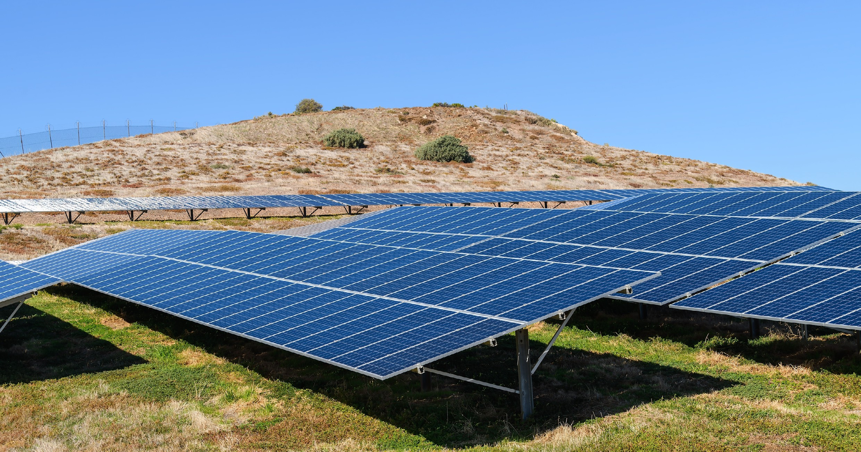

# Transmission Infrastructure Projects

## AEMO Final 2024 Integrated System Plan (ISP)

|  |  |  |  |  |
| --- | --- | --- | --- | --- |
| **Name** | **Description** | **Status** | **Timing** | **Costs** |
| Mid North SA REZ Expansion | New 275kV and 132kV transmission lines to connect renewable generation to Adelaide and to supply increasing industrial load. | Actionable (progressed from Future in Draft 2024 ISP) | Jul 2029  (previously 2027-28) | $389 m (±50%)  (in 2023  $ terms) |

# Employment

|  |  |  |
| --- | --- | --- |
| **Indicator (2021 Census unless otherwise stated)[8]** | **Adelaide** | **SA** |
| Average working age | 38 | 39 |
| Median income (annual gross, exc. super) | $33.8K - $41.6K | $33.8K - $41.6K |
| Participation in workforce | 62% | 60% |
| Female participation in workforce | 58% | 57% |
| Unemployment rate (Dec 2024) | 4.1% | 4.0% |
| Regional Labour Market Index (Dec 2024) | Poor – Above average[9] | N/A |

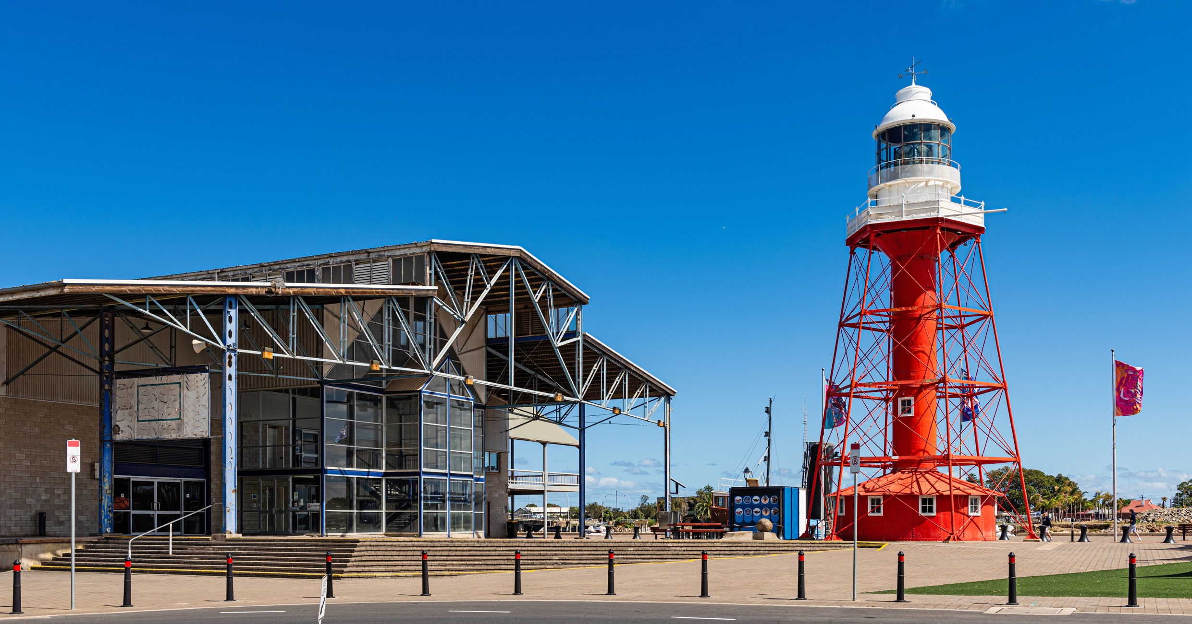

# Demographics

|  |  |  |
| --- | --- | --- |
| **Indicator (2021 Census)** | **Adelaide** | **SA** |
| Median age | 38 | 40 |
| First Nations (% of population) | 2% | 2% |
| Population growth (2016-2021) | 5% | 6% |
| Educational attainment (% of population aged 15 & above):[10] | 39% | 44% |
| * Below Y12 |
| * Y12 or equivalent | 61% | 56% |
| * Cert III & IV | 17% | 19% |
| * Bachelor and above | 29% | 24% |

**Housing**

|  |  |  |
| --- | --- | --- |
| **Indicator (2021 Census unless otherwise stated)** | **Adelaide** | **SA** |
| Homelessness[11] | 0.4% | 0.4% |
| Commonwealth Rent Assistance (Dec 2024)[12] | 5% | 5% |
| Mortgage stress[13] | 13% | 12% |
| Rental stress[14] | 31% | 31% |

# Map highlights location of operating coal mines, coal fired power stations and gas fired power stations in AdelaideMap of Region – Power Stations

# Map highlights location of safeguard facilities in AdelaideMap of Region – Safeguards

Net Zero Economy Authority | Adelaide Regional Profile | June 2025 7

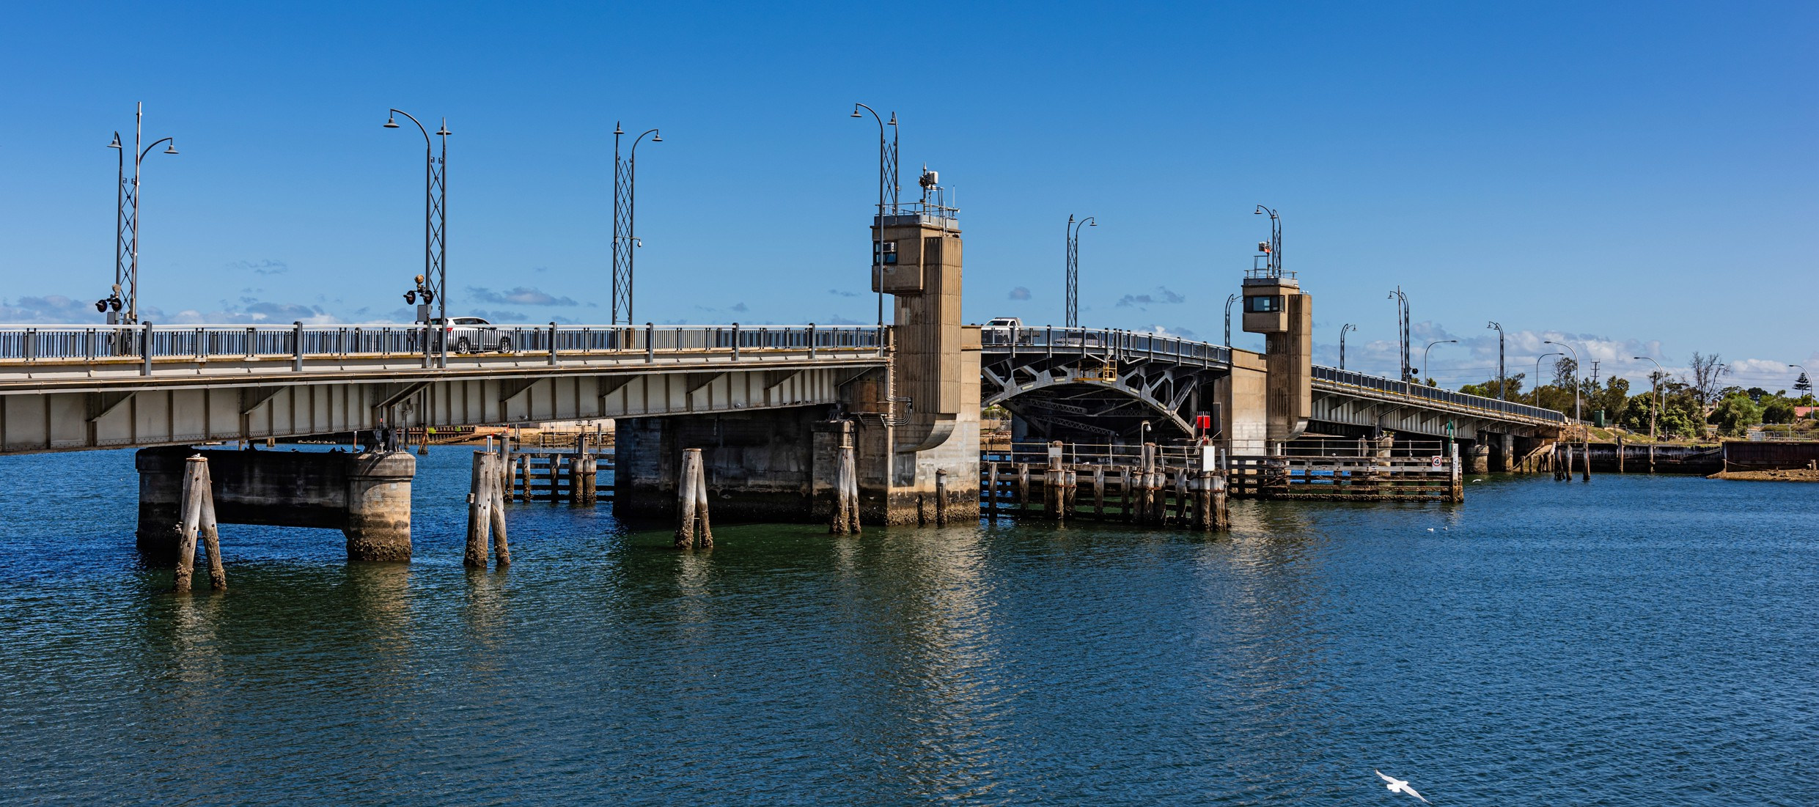

# Data Sources

|  |  |  |
| --- | --- | --- |
| **Section** | **Source** | **Date** |
| **Overview** |  |  |
| Total Population | [Census](https://www.abs.gov.au/statistics/microdata-tablebuilder/tablebuilder), ABS | 2021 |
| Area | [Mesh Blocks - SA2 Allocation Files](https://www.abs.gov.au/statistics/standards/australian-statistical-geography-standard-asgs-edition-3/jul2021-jun2026/access-and-downloads/allocation-files), ABS | 2021 |
| **Region Focus Rationale** |  |  |
| All | [Regional identification framework](https://www.netzero.gov.au/sites/default/files/documents/2025-03/NZEA_Regional_Framework%20%281%29.pdf) | Feb 2025 |
| Emissions | [Safeguard facilities data](https://cer.gov.au/markets/reports-and-data/safeguard-data/2023-24-baselines-and-emissions-data), CER | 2023-24 |
| **Carbon Intensive Industries** |  |  |
| Gas Fired Power Stations | [Greenhouse and energy information by designated](https://cer.gov.au/markets/reports-and-data/nger-reporting-data-and-registers/electricity-sector-emissions-and-generation-data-2023-24) [generation facility](https://cer.gov.au/markets/reports-and-data/nger-reporting-data-and-registers/electricity-sector-emissions-and-generation-data-2023-24), CER  [Greenhouse and energy information - published data](https://cer.gov.au/markets/reports-and-data/nger-reporting-data-and-registers/2023-24-published-data-highlights) [highlights](https://cer.gov.au/markets/reports-and-data/nger-reporting-data-and-registers/2023-24-published-data-highlights) (SA) | 2023-24 |
| Power station closure dates | [Generation Information](https://aemo.com.au/energy-systems/electricity/national-electricity-market-nem/nem-forecasting-and-planning/forecasting-and-planning-data/generation-information)[15]a, AEMO | January 2025 |
| Safeguard facilities | [Safeguard facilities data](https://cer.gov.au/markets/reports-and-data/safeguard-data/2023-24-baselines-and-emissions-data), CER | 2023-24 |
| **Major Industries** |  |  |
| Ranked Industries by most value | [Economic data](https://www.remplan.com.au/)[16]b, REMPLAN | 2025 |
| Ranked Employing Industries | [Census](https://www.abs.gov.au/statistics/microdata-tablebuilder/tablebuilder), ABS | 2021 |
| **Major Investments** |  |  |
| All | [Funded projects](https://arena.gov.au/projects/?project-value-start=0&project-value-end=200000000), ARENA [HyResource](https://research.csiro.au/hyresource/projects/projects-spreadsheet/)[17]c, CSIRO  [Resources and Energy Major Projects](https://www.industry.gov.au/publications/resources-and-energy-major-projects-2024), DISR | 2025  2025  2024 |

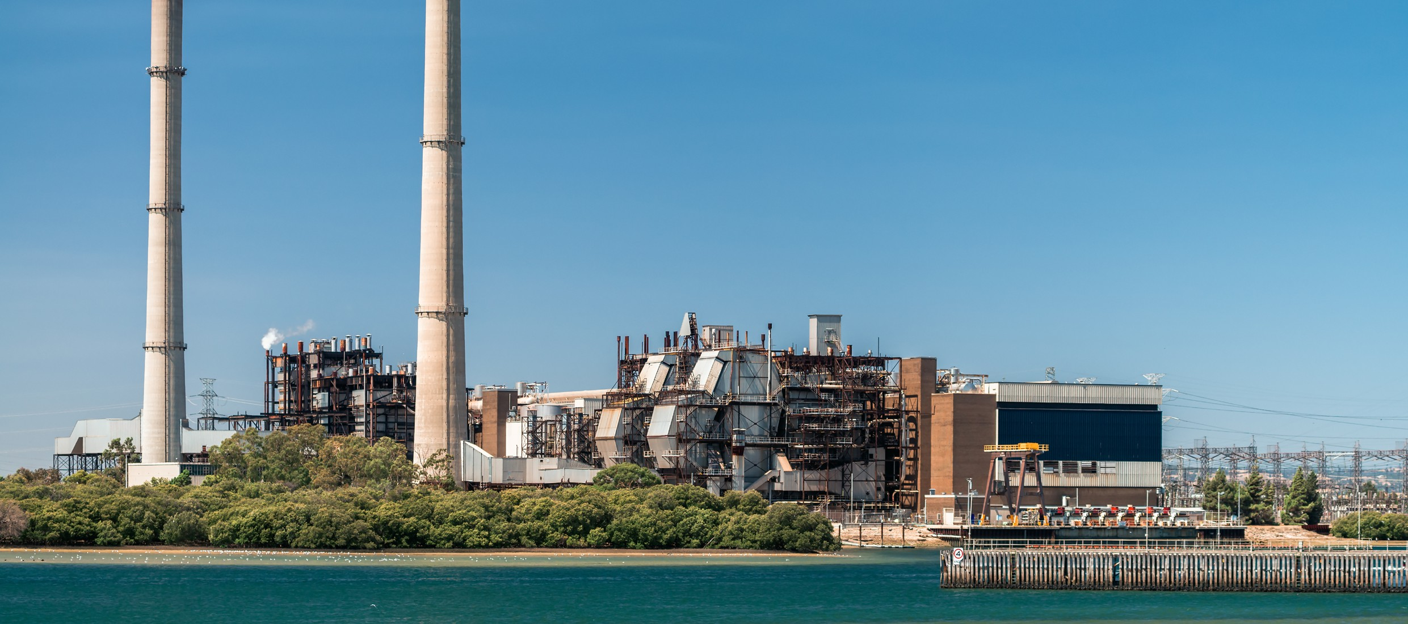

|  |  |  |
| --- | --- | --- |
| **Section** | **Source** | **Date** |
| **Transmission Infrastructure Projects** |  |  |
| All | [Integrated System Plan](https://aemo.com.au/en/energy-systems/major-publications/integrated-system-plan-isp/2024-integrated-system-plan-isp)[18]d, AEMO | June 2024 |
| **Employment** |  |  |
| Average working age, median income, labour force participation | [Census](https://www.abs.gov.au/statistics/microdata-tablebuilder/tablebuilder), ABS | 2021 |
| Regional Labour Market Index | [Regional Labour Market Indicator, Jobs and Skills Australia](https://www.jobsandskills.gov.au/data/regional-labour-market-indicator) | December 2024 |
| Unemployment rate: |  |  |
| * Adelaide * SA | [Small Area Labour Markets](https://www.dewr.gov.au/employment-research/small-area-labour-markets), Jobs and Skills Australia [Labour Force, Australia](https://www.abs.gov.au/statistics/labour/employment-and-unemployment/labour-force-australia/dec-2024#states-and-territories), ABS | December 2024  December 2024 |
| Demographics |  |  |
| All | [Census](https://www.abs.gov.au/statistics/microdata-tablebuilder/tablebuilder), ABS | 2021 |
| **Housing** |  |  |
| Homelessness, mortgage stress, rental stress | [Census](https://www.abs.gov.au/statistics/microdata-tablebuilder/tablebuilder), ABS | 2021 |
| Commonwealth Rental Assistance | [Benefit and Payment Recipient Demographics - quarterly](https://data.gov.au/data/dataset/dss-payment-demographic-data/resource/38a5c0c7-5246-428b-bc0c-3d1fe153ea78) [data](https://data.gov.au/data/dataset/dss-payment-demographic-data/resource/38a5c0c7-5246-428b-bc0c-3d1fe153ea78), DSS | December 2024 |
| **Maps** |  |  |
| All | Produced using data from [Australian Bureau of Agricultural](https://www.agriculture.gov.au/abares#%3A~%3Atext%3DWelcome%20to%20the%20Australian%20Bureau%2Cof%20Agriculture%2C%20Fisheries%20and%20Forestry) [and Resource Economics and Sciences (ABARES)](https://www.agriculture.gov.au/abares#%3A~%3Atext%3DWelcome%20to%20the%20Australian%20Bureau%2Cof%20Agriculture%2C%20Fisheries%20and%20Forestry), DAFF | December 2023 |

Note: All datasets maintained by third party providers listed above and date reflects most recent data available.

1. Adelaide & surrounds comprises the 4 Adelaide statistical area level 4s (SA4s) (Central and Hills, North, South, West but excludes Adelaide Hills and Onkaparinga statistical areas level 3 (SA3s), mirroring boundaries used for the EIJP.
2. a Access may be restricted on a secure network: https://aemo.com.au/energy-systems/electricity/national-electricity- market-nem/nem-forecasting-and-planning/forecasting-and-planning-data/generation-information
3. Data sourced using REMPLAN (incorporating ABS 2021 Census Place of Work Employment (Scaled); 2022 / 2023 National Input Output Tables; June 2024 Gross State Product figures)
4. Data by usual residence means only employees living in Adelaide region would be captured (regardless of whether or not they actually work in Adelaide).
5. Data by place of work means only employees working in Adelaide region would be captured (regardless of whether or not they actually reside in Adelaide).
6. Note, for purposes of calculating shares of workforce, total of 529,019 was used (total workforce minus those workers in ‘Industry of Employment’ categories listed as ‘inadequately described’ and ‘not stated’).
7. Note, for purposes of calculating shares of workforce, total of 549,304 was used (total workforce minus those workers in ‘Industry of Employment’ categories listed as ‘inadequately described’ and ‘not stated’).
8. Census data used here is based on ‘usual residence’ and not ‘place of work’
9. This range (‘Poor’ – ‘Above average’) applies to the four Adelaide SA4s (noting Adelaide Hills and Onkaparinga SA3s are excluded from NZEA’s Adelaide regional definition). Adelaide – North (Poor); Adelaide – West (Average); Adelaide – Central & Hills and Adelaide – South (Above average)
10. Excludes ‘not stated’ and categories are not cumulative
11. Share of population
12. Share of population
13. Share of households where repayments are >30% of household income
14. Share of households where rent payments are >30% of household income
15. a Access may be restricted on a secure network: https://aemo.com.au/energy-systems/electricity/national-electricity- market-nem/nem-forecasting-and-planning/forecasting-and-planning-data/generation-information
16. b Access may be restricted on a secure network: https://research.csiro.au/hyresource/projects/projects-spreadsheet/
17. c Access may be restricted on a secure network: https://research.csiro.au/hyresource/projects/projects-spreadsheet/
18. d Access may be restricted on a secure network: https://aemo.com.au/en/energy-systems/major-publications/integrated- system-plan-isp/2024-integrated-system-plan-isp