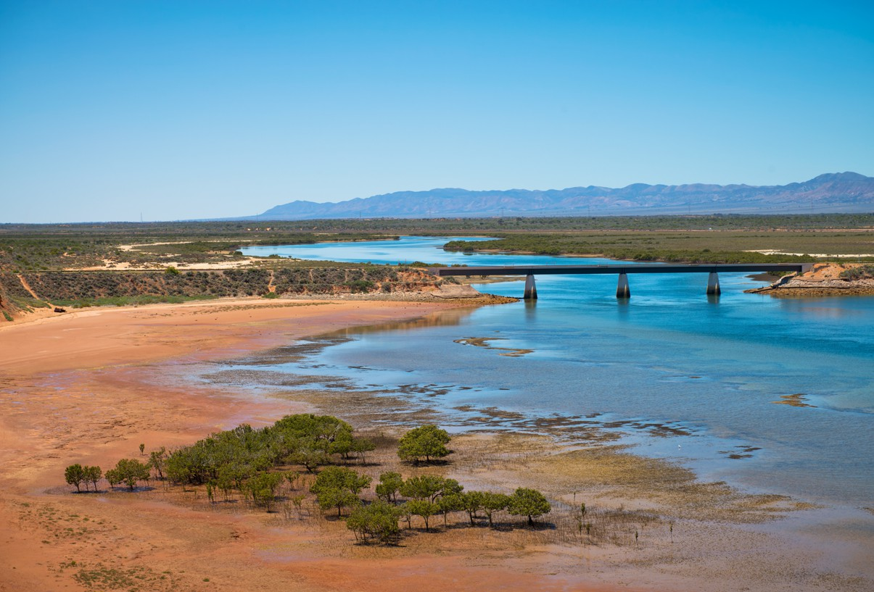

Regional Profiles

**Upper Spencer Gulf**

**Total Area:** 56,076 sq. km **Population:** 68,180 **Working Zones:** Jamestown, Kimba-Cleve-Franklin Harbour, Peterborough-Mount Remarkable, Port Augusta and Quorn-Lake Gilles, Port Pirie and region, Whyalla and Whyalla North *(maps at end of profile)*

# Region Selection Rationale

|  |  |
| --- | --- |
| **Exposure to decarbonisation** | **Potential to harness economic opportunities from decarbonisation** |
| * **Carbon Intensity:** 4 safeguards, accounting for 34% of SA’s scope 1 safeguard emissions * **Adaptive Capacity:** Very low in Upper Spencer Gulf, with Port Augusta, Port Pirie and Whyalla all sitting in the second lowest decile. | * **Natural capital:** Primarily concentrated in its strong renewable energy potential and its extremely high green industry potential, reflected in presence of existing industrial facilities. * **Workforce compatibility:** High proportion of workers in Whyalla are in jobs highly compatible with clean energy industries. There is moderate compatibility across the rest of the region. * **Enabling infrastructure:** Strong position - existing and proposed transport infrastructure. Construction projects include the $13 billion Port Bonython Hydrogen Hub, an announced new large-scale clean hydrogen production precinct for both export and domestic markets. |

**Carbon-Intensive Industries**

**Safeguard Facilities (Emit 100,000+ tonnes CO2 annually - power stations connected to grid are exempt)**

|  |  |  |  |  |
| --- | --- | --- | --- | --- |
| **Type** | **No.** | **Scope 1 emissions (tCO2-e (23/24)** | **% of SA scope 1 safeguard emissions (23/24)** | **% of Aus scope 1 safeguard emissions (23/24)** |
| Liberty Primary Steel Whyalla Steelworks | 1 | 1,191,510 | 21.7% | 0.8% |
| Nyrstar Port Pirie Facility (multi-metals processing) | 1 | 441,897 | 8.0% | 0.3% |
| Port Bonython Plant (oil & gas extraction) | 1 | 82,939 | 1.5% | 0.1% |
| SIMEC Mining - Middleback Range Iron Ore Mine (Whyalla) | 1 | 127,129 | 2.3% | 0.1% |
| Total safeguards | 4 | 1,843,475 | 33.5% | 1.2% |

# Major Industries

**Gross Regional Product (GRP): $5.7 billion (4.0% of SA’s Gross State Product)[1]**

|  |  |  |
| --- | --- | --- |
| **Ranked Industries with most value** | **Value (m)** | **% of GRP** |
| Mining | $1,365.4 | 24.1% |
| Rental, Hiring & Real Estate Services | $622.2 | 11.0% |
| Agriculture, Forestry & Fishing | $509.9 | 9.0% |
| Health Care & Social Assistance | $499.0 | 8.8% |
| Manufacturing | $480.0 | 8.5% |

|  |  |  |  |
| --- | --- | --- | --- |
| **Ranked Employing Industries (by usual residence[2])** | **No. of employees (% of workforce)** | **Ranked Employing Industries (by place of work[3])** | **No. of employees (% of workforce)** |
| Total labour force living in region | 28,160[4] | Total labour force working in region | 27,016[5] |
| Health Care and Social Assistance | 4,399 (16%) | Health Care and Social Assistance | 4,392 (17%) |
| Retail & Wholesale Trade | 3,257 (12%) | Retail & Wholesale trade | 3,224 (12%) |
| Manufacturing | 2,714 (10%) | Manufacturing | 2,765 (11%) |
| Education & Training | 2,514 (9%) | Education & Training | 2,560 (10%) |
| Agriculture, Forestry & Fishing | 2,301 (8%) | Agriculture, Forestry & Fishing | 2,179 (8%) |

# Major Investments

**Major clean energy and heavy industry projects (excluding cancelled and completed) (top projects by value)**

|  |  |  |  |  |
| --- | --- | --- | --- | --- |
| **Project** | **Description** | **Category** | **Status** | **Value** |
| Port Bonython Hydrogen Hub | A new large-scale clean hydrogen production precinct for both export and domestic markets | Green hydrogen | Announced | $13,000 m |
| Northern Water | A new desalination plant and 600km pipeline network to create a reliable water supply | Water | Feasibility | $5,900 m |
| Eyre Peninsula Gateway Project | A new electrolysis plant and an ammonia synthesis facility to supply domestic markets and support trial export shipments of renewables-based hydrogen to Asian markets | Green hydrogen | Under construction | $240 m |
| Vast Solar Port Augusta Concentrated Solar Thermal Power Project | A new solar Concentrated Solar Thermal Power (CSP) plant including energy generation and storage capacity | Renewable energy | Feasibility | $203 m |

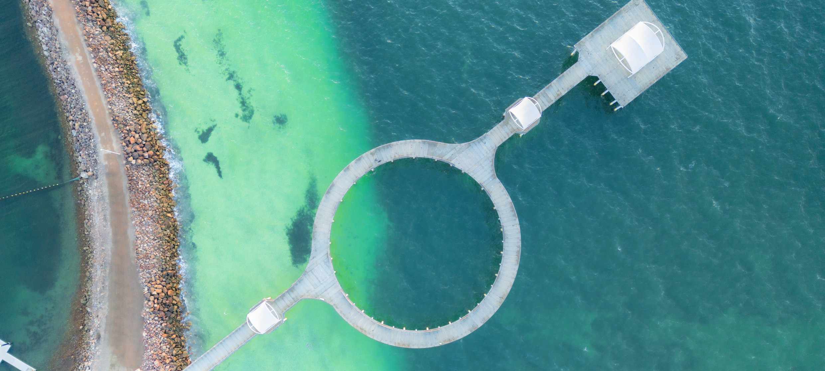

# Transmission Infrastructure Projects

**AEMO Final 2024 Integrated System Plan (ISP)**

|  |  |  |  |  |
| --- | --- | --- | --- | --- |
| **Name** | **Description** | **Status** | **Timing** | **Costs** |
| Project EnergyConnect | New 330kV double-circuit interconnector between SA and NSW, with a new 220kV double-circuit line to Vic. | Committed (unchanged from Draft 2024 ISP) | Dec 2024  - Stage 1 (unchanged) | Approx.  $2,300 m |
| Mid North SA REZ Expansion | New 275kV and 132kV transmission lines to connect renewable generation to Adelaide and to supply increasing industrial load | Actionable (progressed from Future in Draft 2024 ISP) | July 2027  – Stage 2 (previously July 2026) | $389 m (±50%) (in  2023 $ terms) |
| Mid North SA REZ Extension | New network investment project appearing for first time in AEMO ISP. | Future (listed for first time (i.e. not in Draft ISP)) | 2029-30 – both options (not in Draft ISP) | $70 m (±50%)  for Option 1b.  $350mn (±50%) for Option 1a |

# Employment

|  |  |  |
| --- | --- | --- |
| **Indicator (2021 Census unless otherwise stated)[6]** | **USG** | **SA** |
| Average working age | 41 | 39 |
| Median income (annual gross, exc. super) | $26K - $33.8K | $33.8K - $41.6K |
| Participation in workforce | 54% | 60% |
| Female participation in workforce | 51% | 57% |
| Unemployment rate (Dec 2024) | 5.8% | 4.0% |
| Regional Labour Market Index (Mar 2025) | Poor[7] | N/A |

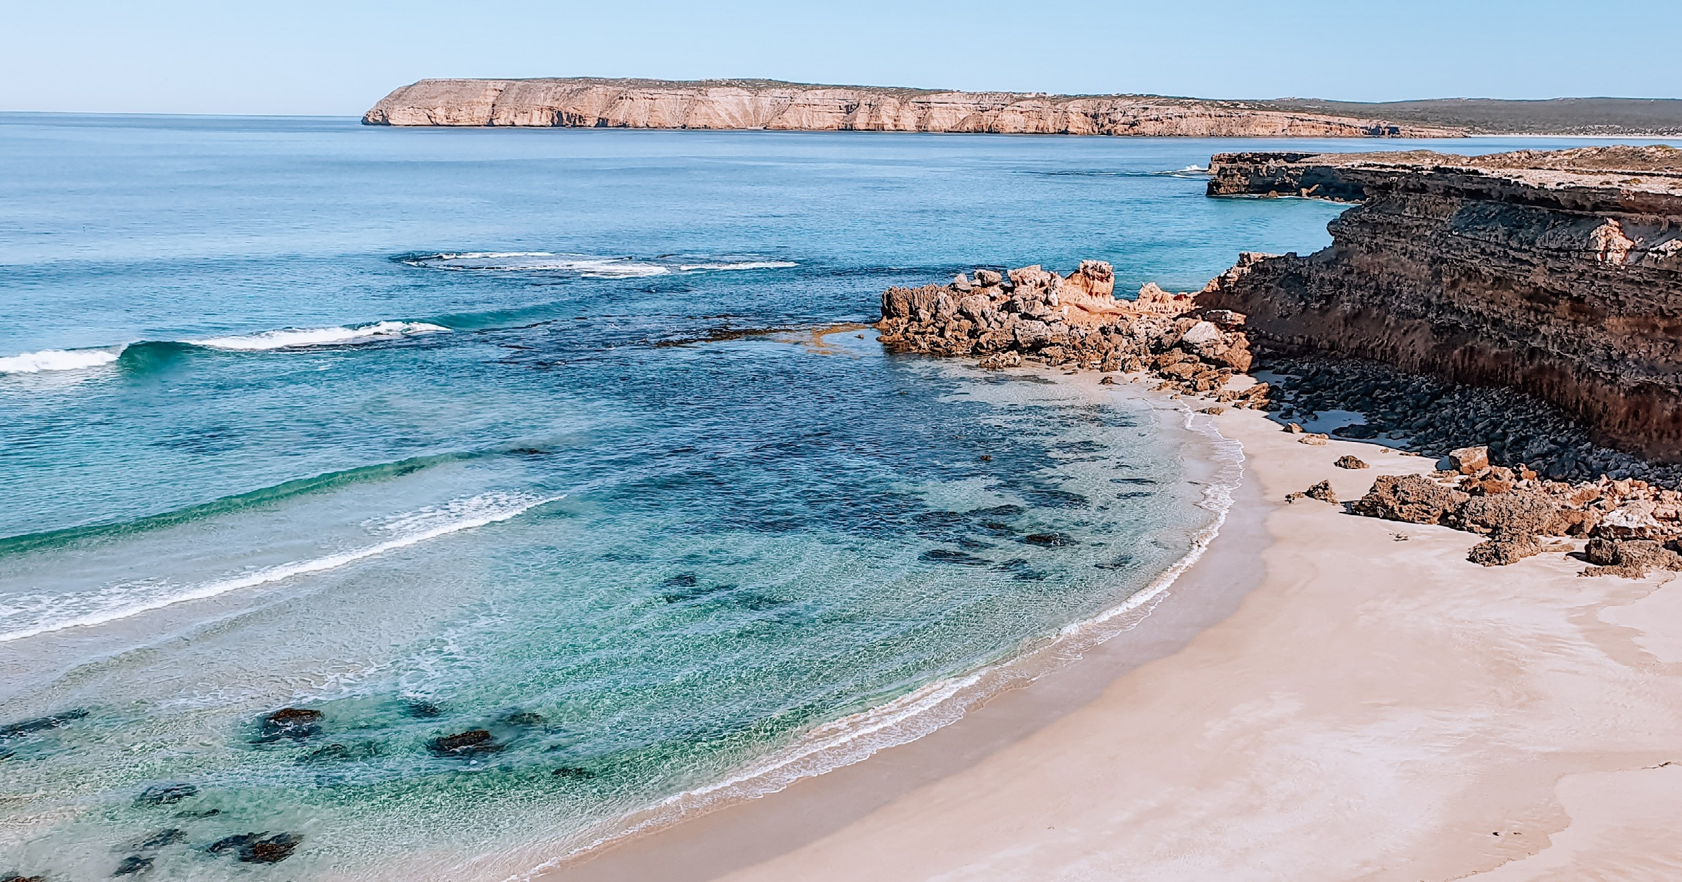

# Demographics

|  |  |  |
| --- | --- | --- |
| **Indicator (2021 Census)** | **USG** | **SA** |
| Median age | 43 | 40 |
| First Nations (% of population) | 8% | 2% |
| Population growth (2016-2021) | -1% | 6% |
| Educational attainment (% of population aged 15 & above):[8] | 62% | 44% |
| * Below Y12 |
| * Y12 or equivalent | 38% | 56% |
| * Cert III & IV | 24% | 19% |
| * Bachelor and above | 11% | 24% |

**Housing**

|  |  |  |
| --- | --- | --- |
| **Indicator (2021 Census unless otherwise stated)** | **USG** | **SA** |
| Homelessness[9] | 0.9% | 0.4% |
| Commonwealth Rent Assistance (Dec 2024)[10] | 6% | 5% |
| Mortgage stress[11] | 9% | 12% |
| Rental stress[12] | 23% | 31% |

# Map highlights location of operating coal mines, coal fired power stations and gas fired power stations in the Upper Spencer GulfMap of Region – Power Stations

Net Zero Economy Authority | Upper Spencer Gulf Regional Profile | June 2025 5

# Map highlights location of safeguard facilities in the Upper Spencer GulfMap of Region – Safeguards

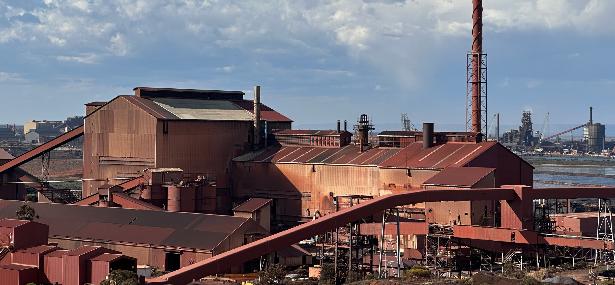

**Data Sources**

|  |  |  |
| --- | --- | --- |
| **Section** | **Source** | **Date** |
| **Overview** |  |  |
| Total Population | [Census](https://www.abs.gov.au/statistics/microdata-tablebuilder/tablebuilder), ABS | 2021 |
| Area | [Mesh Blocks - SA2 Allocation Files](https://www.abs.gov.au/statistics/standards/australian-statistical-geography-standard-asgs-edition-3/jul2021-jun2026/access-and-downloads/allocation-files), ABS | 2021 |
| **Priority Region Selection Rationale** |  |  |
| All | [Regional identification framework](https://www.netzero.gov.au/sites/default/files/documents/2025-03/NZEA_Regional_Framework%20%281%29.pdf) | February 2025 |
| **Carbon Intensive Industries** |  |  |
| Gas Fired Power Stations | [Greenhouse & energy information by designated generation](https://cer.gov.au/markets/reports-and-data/nger-reporting-data-and-registers/electricity-sector-emissions-and-generation-data-2023-24) [facility](https://cer.gov.au/markets/reports-and-data/nger-reporting-data-and-registers/electricity-sector-emissions-and-generation-data-2023-24), CER  [Greenhouse & energy information - data highlights](https://cer.gov.au/markets/reports-and-data/nger-reporting-data-and-registers/2023-24-published-data-highlights) (SA) | 2023-24 |
| Power station closure dates | [Generation Information](https://aemo.com.au/energy-systems/electricity/national-electricity-market-nem/nem-forecasting-and-planning/forecasting-and-planning-data/generation-information)[13]a, AEMO | April 2025 |
| Safeguard facilities | [Safeguard facilities data](https://cer.gov.au/markets/reports-and-data/safeguard-data), CER | 2023-24 |
| **Major Industries** |  |  |
| Ranked industries by most value | [Economic data](https://www.remplan.com.au/)[14]b, REMPLAN | 2025 |
| Ranked employing industries | [Census](https://www.abs.gov.au/statistics/microdata-tablebuilder/tablebuilder), ABS | 2021 |
| **Major Investments** |  |  |
| All | [Funded projects](https://arena.gov.au/projects/?project-value-start=0&project-value-end=200000000), ARENA [HyResource](https://research.csiro.au/hyresource/projects/projects-spreadsheet/)[15]c, CSIRO  [Resources and Energy Major Projects](https://www.industry.gov.au/publications/resources-and-energy-major-projects-2024), DISR | 2025  2025  2024 |

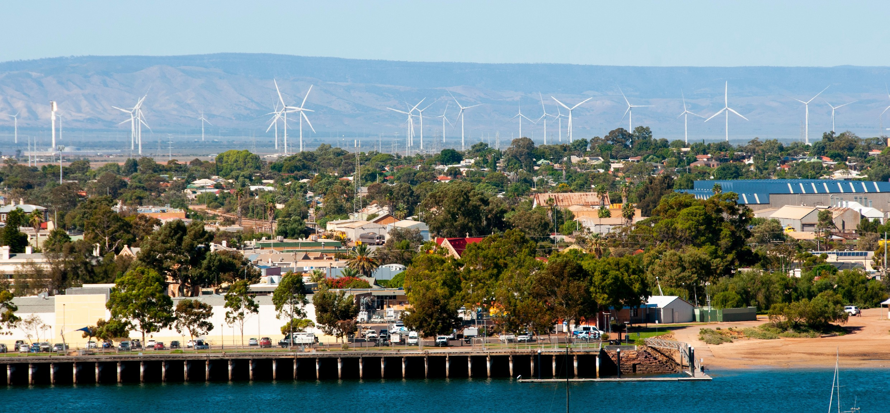

|  |  |  |
| --- | --- | --- |
| **Section** | **Source** | **Date** |
| **Transmission Infrastructure Projects** |  |  |
| All | [Integrated System Plan](https://aemo.com.au/en/energy-systems/major-publications/integrated-system-plan-isp/2024-integrated-system-plan-isp)[16]d, AEMO | June 2024 |
| **Employment** |  |  |
| Average working age, median income, labour force participation | [Census](https://www.abs.gov.au/statistics/microdata-tablebuilder/tablebuilder), ABS | 2021 |
| Regional Labour Market Index | [Regional Labour Market Indicator, Jobs and Skills Australia](https://www.jobsandskills.gov.au/data/regional-labour-market-indicator) | March 2025 |
| Unemployment rate: |  |  |
| * Upper Spencer Gulf * SA | [Small Area Labour Markets](https://www.dewr.gov.au/employment-research/small-area-labour-markets#downloads), Jobs and Skills Australia [Labour Force, Australia](https://www.abs.gov.au/statistics/labour/employment-and-unemployment/labour-force-australia/dec-2024), ABS | December 2024  December 2024 |
| **Demographics** |  |  |
| All | [Census](https://www.abs.gov.au/statistics/microdata-tablebuilder/tablebuilder), ABS | 2021 |
| **Housing** |  |  |
| Homelessness, mortgage stress, rental stress | [Census](https://www.abs.gov.au/statistics/microdata-tablebuilder/tablebuilder), ABS | 2021 |
| Commonwealth Rental Assistance | [Benefit and Payment Recipient Demographics - quarterly](https://data.gov.au/data/dataset/dss-payment-demographic-data/resource/38a5c0c7-5246-428b-bc0c-3d1fe153ea78) [data](https://data.gov.au/data/dataset/dss-payment-demographic-data/resource/38a5c0c7-5246-428b-bc0c-3d1fe153ea78), DSS | December 2024 |
| **Maps** |  |  |
| All | Produced using data from [Australian Bureau of Agricultural](https://www.agriculture.gov.au/abares#%3A~%3Atext%3DWelcome%20to%20the%20Australian%20Bureau%2Cof%20Agriculture%2C%20Fisheries%20and%20Forestry) [and Resource Economics and Sciences (ABARES)](https://www.agriculture.gov.au/abares#%3A~%3Atext%3DWelcome%20to%20the%20Australian%20Bureau%2Cof%20Agriculture%2C%20Fisheries%20and%20Forestry), DAFFs | December 2023 |

Note: All datasets maintained by third party providers listed above and date reflects most recent data available.

1. Data sourced using REMPLAN (incorporating ABS 2021 Census Place of Work Employment (Scaled); 2022 / 2023 National Input Output Tables; June 2024 Gross State Product figures)
2. Data by usual residence means only employees living in Upper Spencer Gulf region would be captured (regardless of whether or not they actually work in Upper Spencer Gulf).
3. Data by place of work means only employees working in Upper Spencer Gulf region would be captured (regardless of whether or not they actually reside in Upper Spencer Gulf).
4. Note, for purposes of calculating shares of workforce, total of 27,305 was used (total workforce minus those workers in ‘Industry of Employment’ categories listed as ‘inadequately described’ and ‘not stated’).
5. Note, for purposes of calculating shares of workforce, total of 26,185 was used (total workforce minus those workers in ‘Industry of Employment’ categories listed as ‘inadequately described’ and ‘not stated’).
6. Census data used here is based on ‘usual residence’ and not ‘place of work’.
7. This index of ‘Poor’ applies to the two SA4s (Barossa - Yorke - Mid North & South Australia – Outback) that cover all of the SA2s (Jamestown, Port Pirie, Port Pirie Surrounds, Kimba - Cleve - Franklin Harbour, Whyalla, Whyalla – North, Quorn

   - Lake Gilles, Port Augusta) in Upper Spencer Gulf. However, it is important to note both of those SA4s also cover SA2s that are not part of the regional definition of Upper Spencer Gulf.
8. Excludes ‘not stated’ and categories are not cumulative
9. Share of population
10. Share of population
11. Share of households where rent payments are >30% of household income
12. Share of households where rent payments are >30% of household income
13. a Access may be restricted on a secure network: https://aemo.com.au/energy-systems/electricity/national-electricity- market-nem/nem-forecasting-and-planning/forecasting-and-planning-data/generation-information
14. b Access may be restricted on a secure network: https://www.remplan.com.au
15. c Access may be restricted on a secure network: https://research.csiro.au/hyresource/projects/projects-spreadsheet/
16. d Access may be restricted on a secure network: https://aemo.com.au/en/energy-systems/major-publications/integrated- system-plan-isp/2024-integrated-system-plan-isp