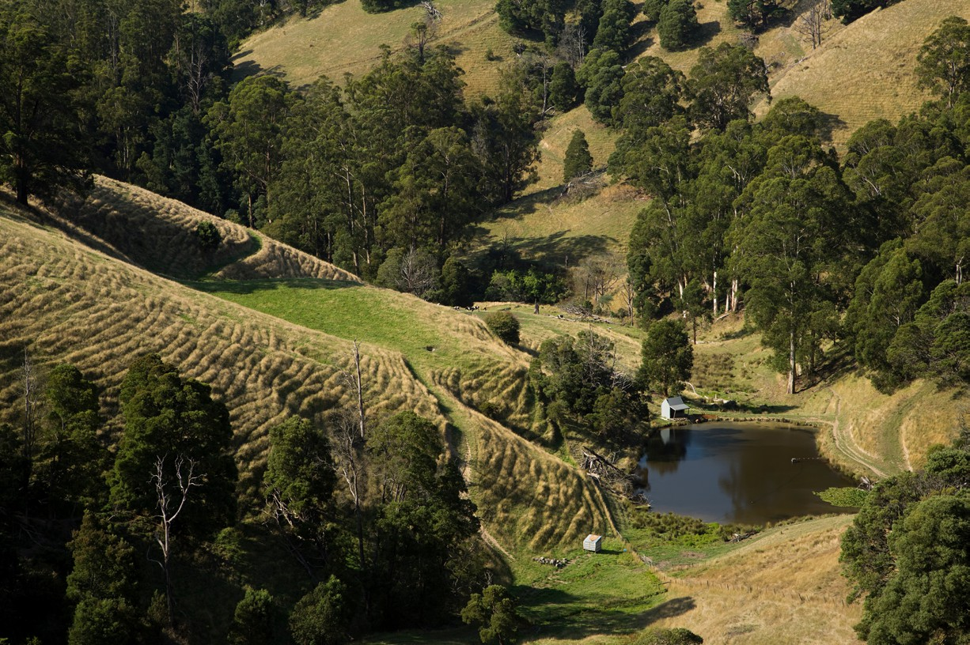

Regional Profiles

**Latrobe Gippsland**

**Total Area:** 41,289 sq. km **Population:** 300,708 **Working Zones:** Drouin, Warragul and surrounds; La Trobe Valley Orbost and Alps-East; Bairnsdale, Lakes Entrance and surrounds; Leongatha and surrounds; Wonthaggi-Inverloch and Phillip Island; Sale and surrounds; Yarram (maps at end of profile)

**Region Selection Rationale**

|  |  |
| --- | --- |
| **Exposure to decarbonisation** | **Potential to harness economic opportunities from decarbonisation** |
| * **Carbon intensity:** 3 coal-fired power stations, 5 gas-fired power stations and 2 safeguards. As of 2023-24, safeguards in the region account for 37% of Vic safeguard scope 1 emissions; region has large amounts of employment in coal power generation and in manufacturing. * **Urgency:** High – two of three power stations expected to close by 2035. * **Adaptive capacity:** Moderate to above average. * **Readiness:** High - there is already strong planning, funding and preparation for decarbonisation, including development of the Latrobe Valley and Gippsland Transition Plan, designed in conjunction with businesses, industries, and local communities. | * **Natural capital:** High offshore wind potential. * **Workforce compatibility:** Moderate number of workers in the region are in jobs highly compatible with clean energy industries. Compatibility is largely consistent across region. * **Enabling infrastructure:** High – Strong road and telecoms connectivity. Gippsland’s proximity to Port of Hastings, a deep-water port allows for hydrogen export. |

**Carbon-Intensive Industries**

**Coal Fired Power Stations (CFPS)**

|  |  |  |  |  |  |  |  |
| --- | --- | --- | --- | --- | --- | --- | --- |
| **Name** |  | **Owner** | **Public closure date (**[**AEMO NEM**](https://aemo.com.au/energy-systems/electricity/national-electricity-market-nem/nem-forecasting-and-planning/forecasting-and-planning-data/generation-information)  [**Gen Apr**](https://aemo.com.au/energy-systems/electricity/national-electricity-market-nem/nem-forecasting-and-planning/forecasting-and-planning-data/generation-information) [**2025**](https://aemo.com.au/energy-systems/electricity/national-electricity-market-nem/nem-forecasting-and-planning/forecasting-and-planning-data/generation-information)**[1]a)** | **Supplying Coal Mine** | **Scope 1 emissions (tCO2-e) (23/24)** | **% of Scope 1 Vic emissions (23/24)** | **% of Scope 1 Aus emissions (23/24)** |
| Yallourn Power Station | | Energy Australia | 2028 | Yallourn | 10,344,727 | 20% | 3% |
| Loy Yang  Power Station A | | AGL | 2035 | Loy Yang | 18,531,075 | 36% | 6% |
| Loy Yang Power Station B | | Alinta Energy | 2047 | Loy Yang | 9,642,473 | 19% | 3% |
| Total | 3 | 3 |  | 2 | 38,518,275 | 75% | 13%[2] |

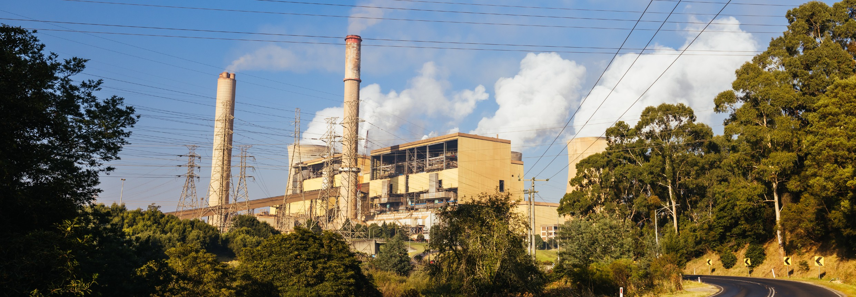

**Gas Fired Power Stations (GFPS)**

|  |  |  |  |  |  |  |
| --- | --- | --- | --- | --- | --- | --- |
| **Name** |  | **Owner** | **Public closure date**  **(**[**AEMO NEM Gen**](https://aemo.com.au/energy-systems/electricity/national-electricity-market-nem/nem-forecasting-and-planning/forecasting-and-planning-data/generation-information)  [**Apr 2025**](https://aemo.com.au/energy-systems/electricity/national-electricity-market-nem/nem-forecasting-and-planning/forecasting-and-planning-data/generation-information)**[3]ba)** | **Scope 1 emissions (tCO2-e) (23/24)** | **% of Vic scope 1 emissions (23/24)** | **% of Aus scope 1 emissions (23/24)** |
| Jeeralang A | | EnergyAustralia | 2039 | 34,838 (across both facilities) |  |  |
| Jeeralang B | | EnergyAustralia | 2039 | 0.1% | 0.01% |
|  |  |
| Valley Aking/ Power | | Snowy Hydro Ltd (Cwth gov.) | 2070 | 17,317 | 0.03% | 0.01% |
| Bairnsdale |  | Alinta Energy | 2042 | 33,601 | 0.1% | 0.01% |
| Longford |  | Exxon Mobil | 2024-2032 | n/a | n/a | n/a |
| Total | 5 | 4 |  | 85,756 | 0.2%[4] | 0.03% |

**Manufacturing**

|  |  |  |  |  |
| --- | --- | --- | --- | --- |
| **Name** | **Owner** | **Scope 1 emissions (tCO2-e) (23/24)** | **% of Vic scope 1 emissions (23/24)** | **% of Aus scope 1 emissions (23/24)** |
| Opal Australian Paper Maryvale Mill | Paper Australia Ltd | 235,738 | 0.5% | 0.1% |

**Safeguard Facilities (Emit 100,000+ tonnes CO2 annually - power stations connected to grid are exempt)**

|  |  |  |  |  |
| --- | --- | --- | --- | --- |
| **Type** | **No.** | **Total scope 1 emissions (tCO2-e) (23/24)** | **% of Vic scope 1 safeguard emissions (23/24)** | **% of Aus scope 1 safeguard emissions (23/24)** |
| Manufacturing (Opal Australian Paper Maryvale Mill) | 1 | 235,738 | 5.0% | 0.2% |
| Oil & gas extraction (Gippsland Basin facility) | 1 | 1,505,497 | 31.9% | 1.2% |
| Total safeguards | 2 | 1,741,235 | 36.8% | 1.4%[5] |

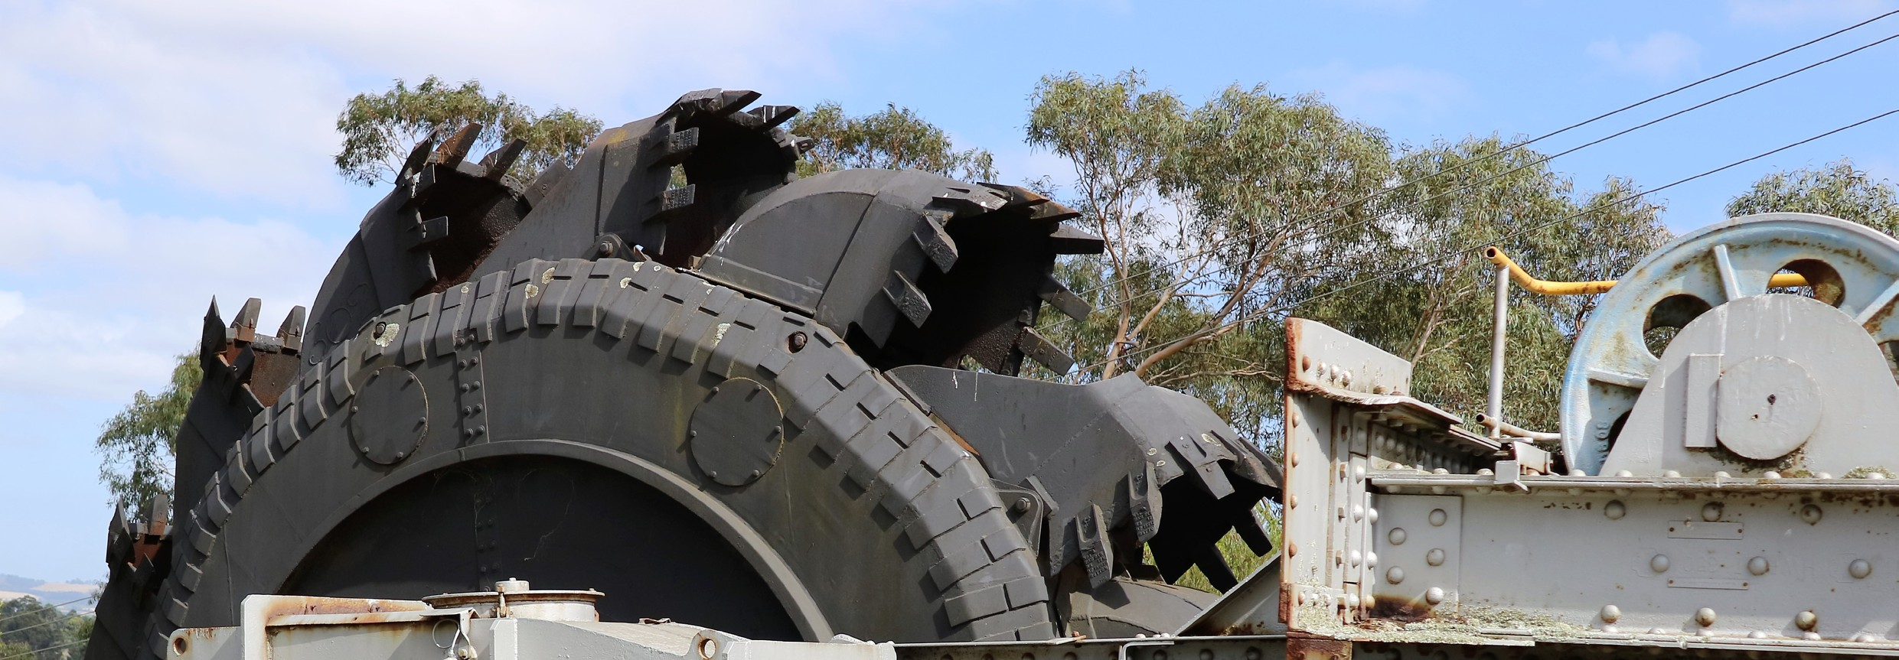

**Major Industries**

**Gross Regional Product (GRP): $23.3 billion (4.1% of VIC’s Gross State Product)[6]**

|  |  |  |
| --- | --- | --- |
| **Ranked Industries with most value** | **Value (m)** | **% of GRP** |
| Rental, Hiring & Real Estate Services | $3,165 | 13.6% |
| Mining | $2,460 | 10.6% |
| Health Care & Social Assistance | $2,337 | 10.0% |
| Agriculture, Forestry & Fishing | $2,290 | 9.8% |
| Construction | $2,203 | 9.5% |

|  |  |  |  |
| --- | --- | --- | --- |
| **Ranked Employing Industries (by usual residence[7])** | **No. of employees (% of workforce)** | **Ranked Employing Industries (by place of work[8])** | **No. of employees (% of workforce)** |
| Total labour force living in region | 127,371[9] | Total labour force working in region | 113,028[10] |
| Healthcare & Social Assistance | 19,698 (16%) | Healthcare & Social Assistance | 18,770 (17%) |
| Retail & Wholesale Trade | 14,674 (12%) | Retail & Wholesale Trade | 13,490 (12%) |
| Construction | 13,861 (11%) | Education | 10,146 (9%) |
| Education | 10,942 (9%) | Construction | 9,763 (9%) |
| Agriculture | 9,580 (8%) | Agriculture | 9,183 (8%) |

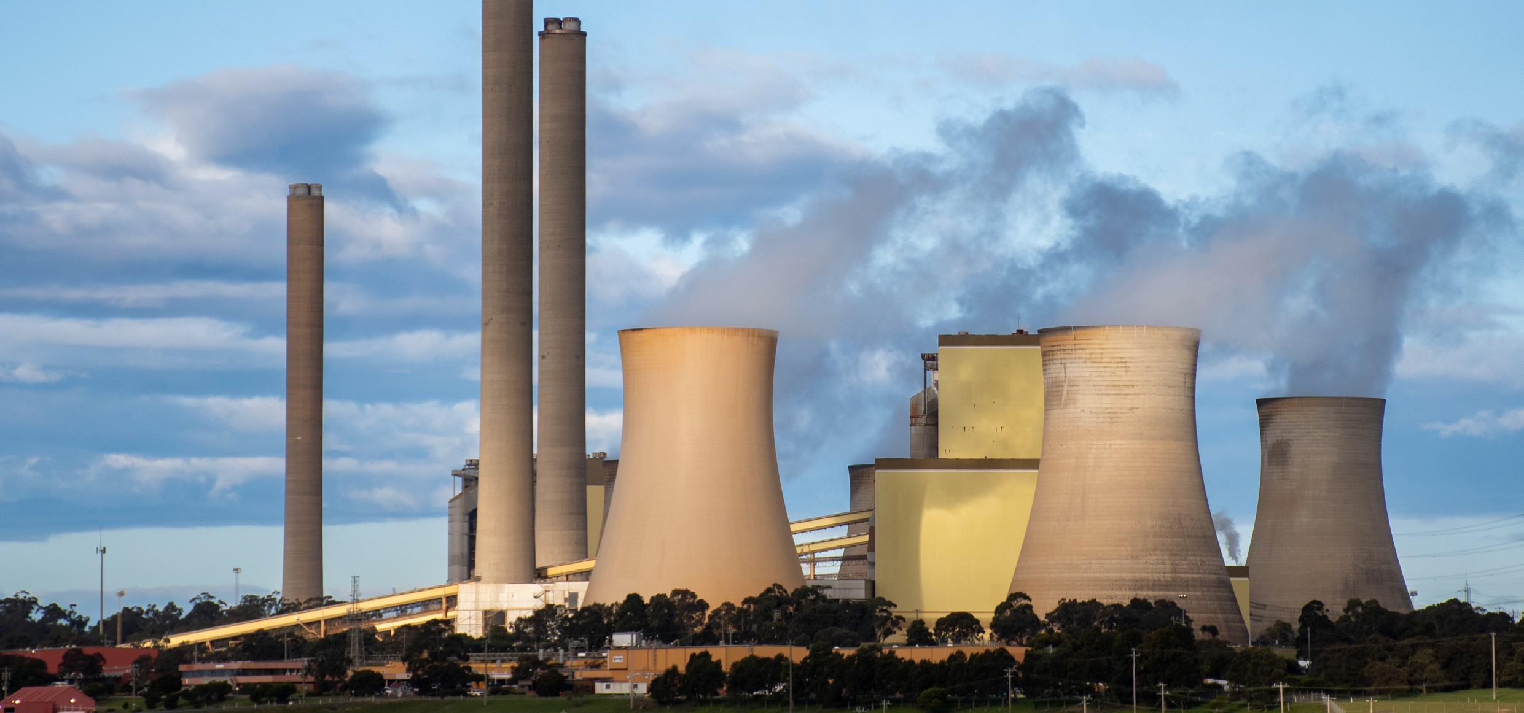

**Major Investments**

**Clean energy and heavy industry projects (excluding cancelled and completed) (top projects by value)**

|  |  |  |  |  |
| --- | --- | --- | --- | --- |
| **Project** | **Description** | **Category** | **Status** | **Value** |
| Gippsland Dawn Offshore Wind Project | Proposed project with up to 2.1 gigawatts of electricity generation capacity. The project would comprise up to 140 offshore wind turbines on fixed foundations, and four offshore substations. Subsea cables will be used to transport the electricity generated to an onshore landing point. | Wind | Announced | $10 b |
| Star of the South Offshore Wind Farm | At up to 2.2 GW, project could potentially power around  1.2 million homes.  The project is being progressed under a feasibility licence in a 586 square km area, 10 km from the coast at its closest point. | Wind | Feasibility | $8 b |
| Wooreen Energy Storage System (WESS) | A four-hour utility-scale battery to store low-cost electricity, such as excess renewable energy, near Yallourn CFPS | Renewable Energy | Under construction | $800 m |
| CarbonNet Project | Proposed 100-kilometre pipeline to take liquefied CO2 to a carbon capture storage (CCS) site beneath the seabed. | CCS | Announced | $150 m |

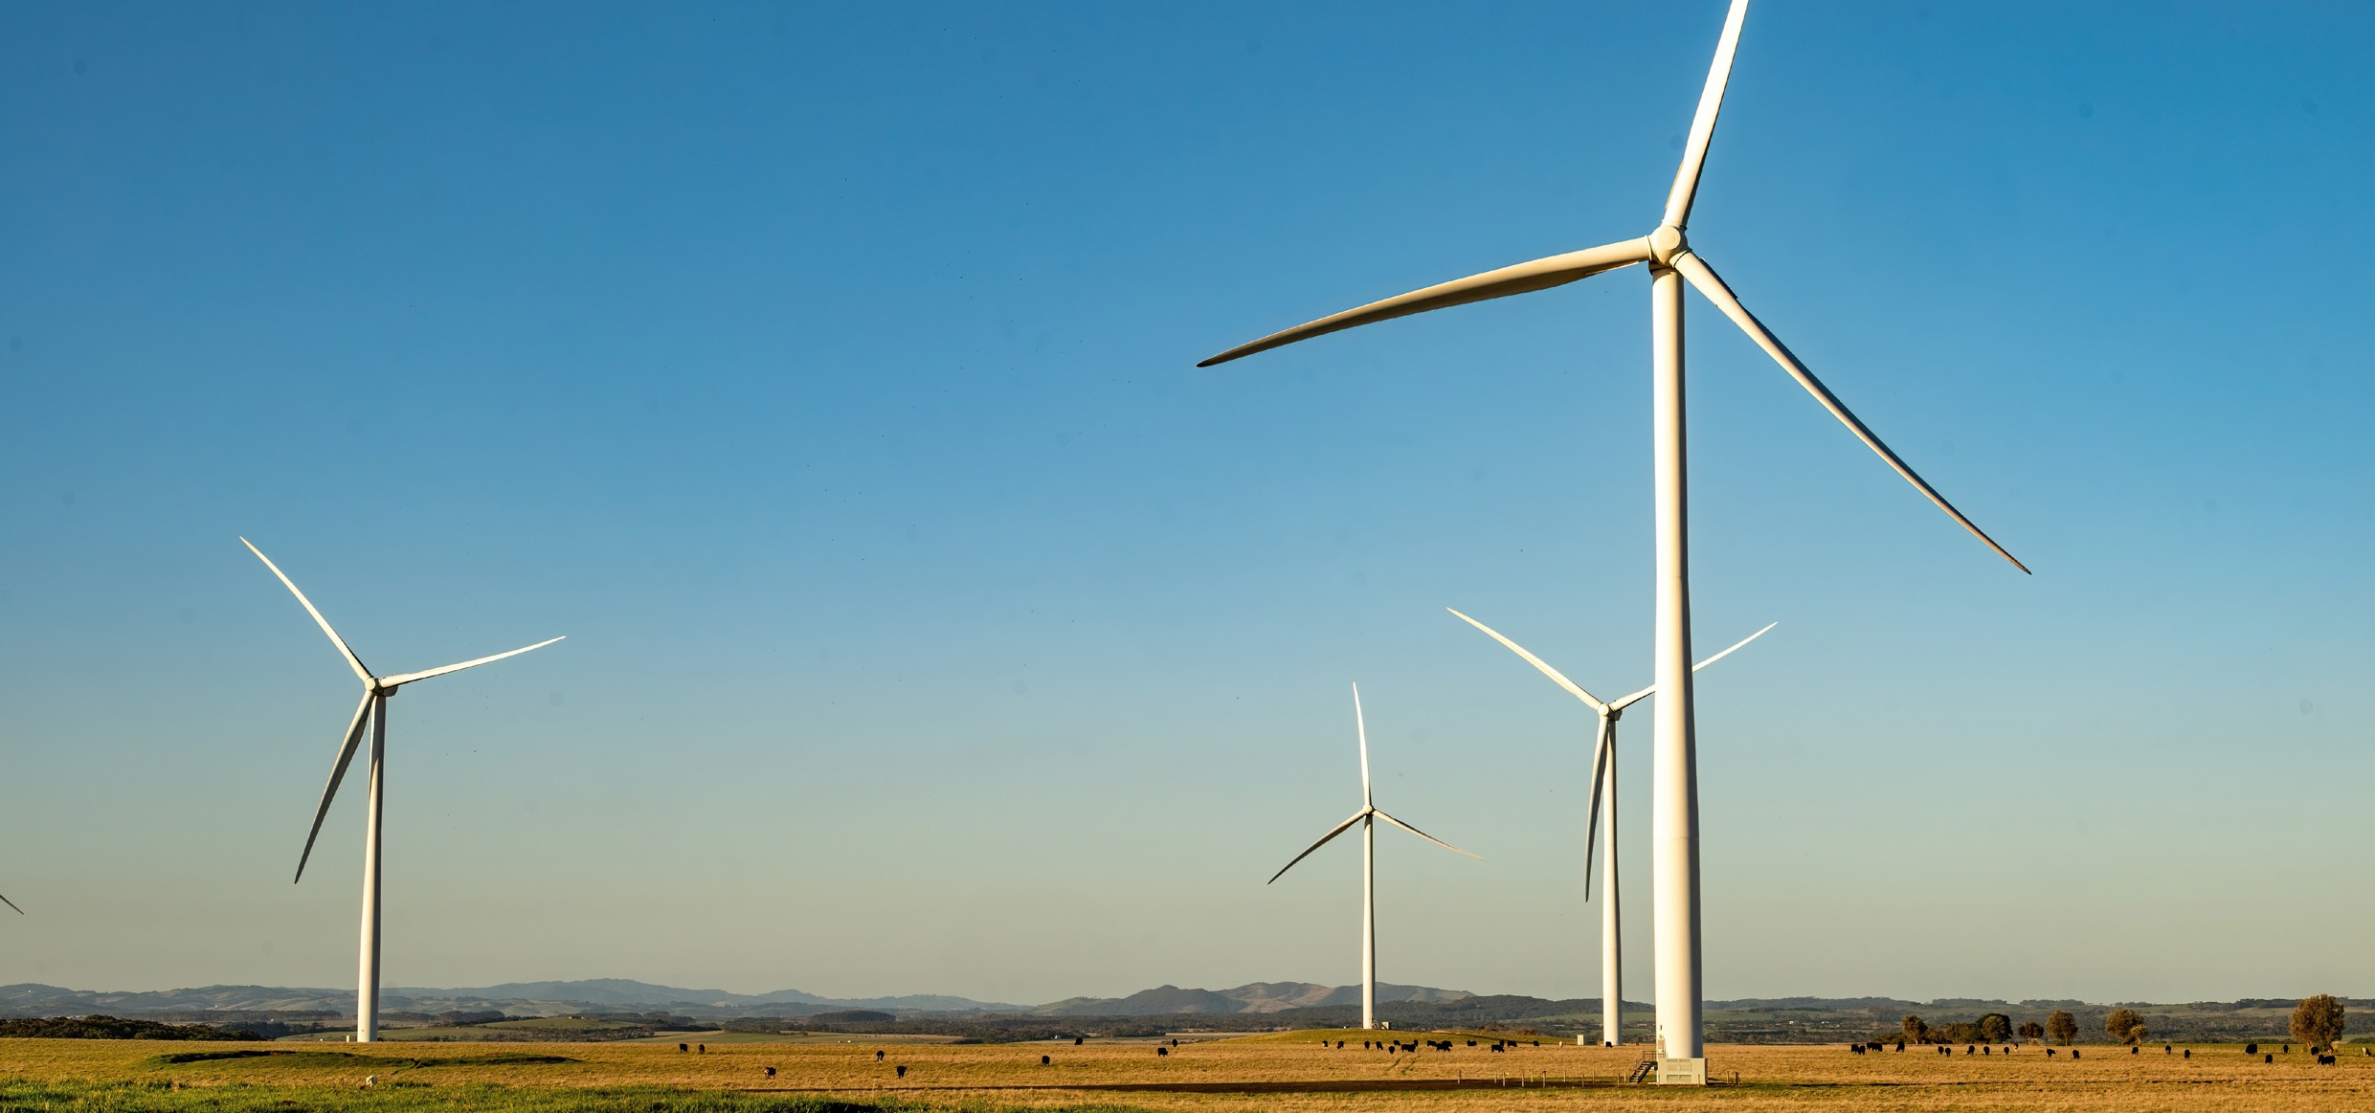

**Transmission Infrastructure Projects**

**AEMO Final 2024 Integrated System Plan transmission infrastructure projects**

|  |  |  |  |  |
| --- | --- | --- | --- | --- |
| **Name** | **Description** | **Status** | **Timing** | **Costs** |
| Project Marinus | Two new high voltage direct current cables connecting Vic (inc. Latrobe) and Tas,  each with 750 MW of transfer capacity & associated AC transmission, to enable  efficient power sharing between regions. HVAC network assets in Tas for REZs under Transmission Developments project. | Actionable | Stage 1  Dec 2030  Stage 2  Dec 2032  (unchanged) | Stage 1:  $3,800 m (±30%).  Stage 2:  $2,700 m (±30%). |
| Eastern Victoria Grid Reinforcement | Add transfer capacity between Latrobe Valley and Melbourne to accommodate increased onshore and new offshore wind power generation. | Future | 2030 - 2031 | $297 m (±50%). |
| Gippsland Offshore Wind Connection | VicGrid is coordinating shared transmission to support offshore wind energy in Vic. | Future | 2027-2030 | $700 m - $1,500 m (overhead)  $2,000 m - $4,500 m  (underground) |

**Employment**

|  |  |  |
| --- | --- | --- |
| **Indicator (2021 Census unless otherwise stated)** | **Latrobe Gippsland** | **Victoria** |
| Average working age | 42 | 38 |
| Median income (annual gross, exc. super) | $26.0K - $33.8K | $41.6K - $52.0K |
| Participation in workforce | 54% | 62% |
| Female participation in workforce | 51% | 59% |
| Unemployment rate (Dec 2024) | 5.0% | 4.5% |
| Regional Labour Market Index (Dec 2024) | Poor[11] | N/A |

**Demographics**

|  |  |  |
| --- | --- | --- |
| **Indicator (2021 Census)** | **Latrobe Gippsland** | **Victoria** |
| Median age | 45 | 37 |
| First Nations (% of population) | 2% | 1% |
| Population growth (2016-2021) | 11% | 10% |
| Educational attainment (% of population aged 15 & above):[12] | 56% | 37% |
| * Below Y12 |
| * Y12 or equivalent | 44% | 63% |
| * Cert III & IV | 24% | 15% |
| * Bachelor and above | 17% | 32% |

**Housing**

|  |  |  |
| --- | --- | --- |
| **Indicator (2021 Census unless otherwise stated)** | **Latrobe Gippsland** | **Victoria** |
| Homelessness[13] | 0.3% | 0.5% |
| Commonwealth Rent Assistance (Dec 2024)[14] | 6% | 5% |
| Mortgage stress[15] | 12% | 15% |
| Rental stress[16] | 34% | 31% |

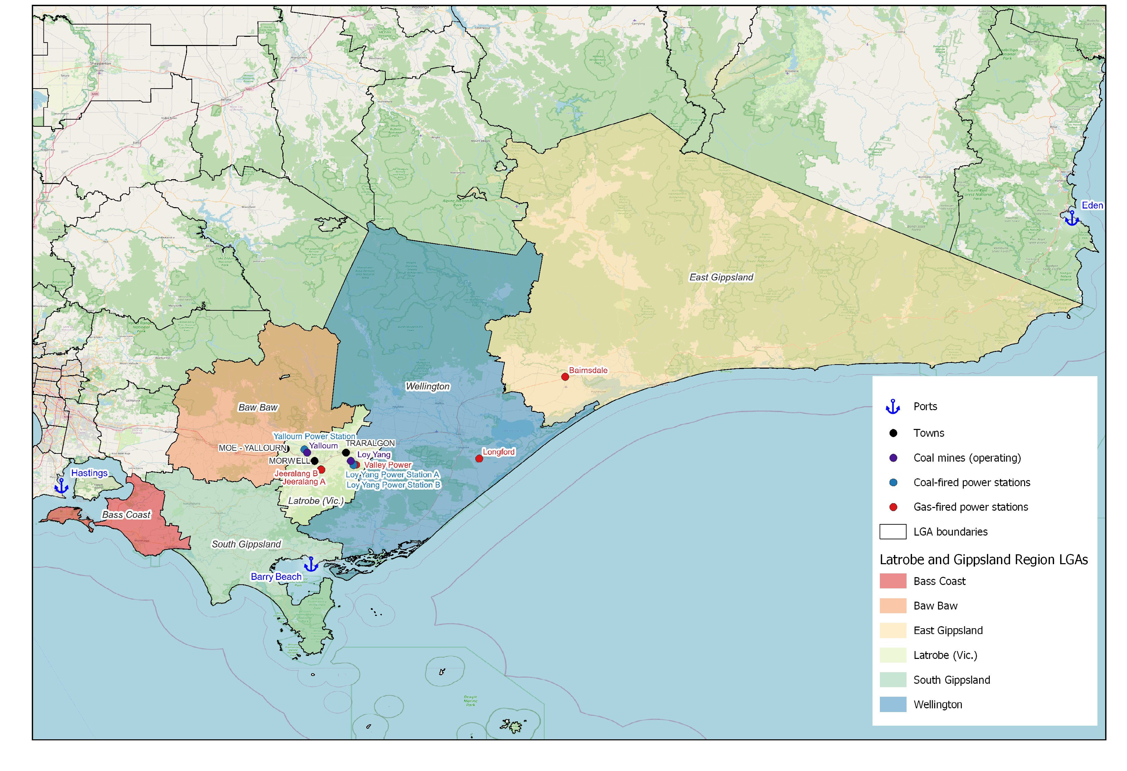**Map of Region – Power Stations and Mines**

Net Zero Economy Authority | Collie Regional Profile | June 2025 7

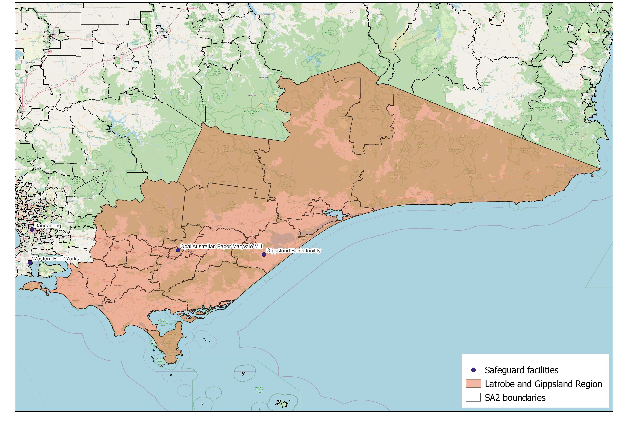**Map of Region – Safeguards**

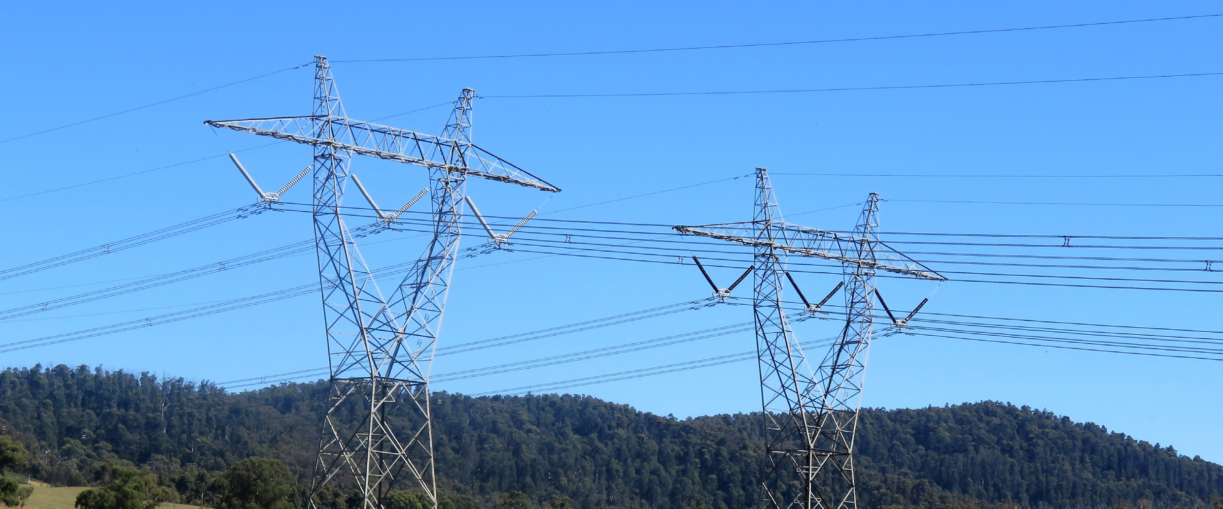

**Data Sources**

|  |  |  |
| --- | --- | --- |
| **Section** | **Source** | **Date** |
| **Overview** |  |  |
| Total Population | [Census](https://www.abs.gov.au/statistics/microdata-tablebuilder/tablebuilder), ABS | 2021 |
| Area | [Mesh Blocks - SA2 Allocation Files](https://www.abs.gov.au/statistics/standards/australian-statistical-geography-standard-asgs-edition-3/jul2021-jun2026/access-and-downloads/allocation-files), ABS | 2021 |
| **Priority Region Selection Rationale** |  |  |
| All | [Regional identification framework](https://www.netzero.gov.au/sites/default/files/documents/2025-03/NZEA_Regional_Framework%20%281%29.pdf) | February 2025 |
| Emissions | [Safeguard facilities data](https://cer.gov.au/markets/reports-and-data/safeguard-data/2023-24-baselines-and-emissions-data), CER | 2023-24 |
| **Carbon Intensive Industries** |  |  |
| Coal Fired Power Stations | [Greenhouse and energy information by designated](https://cer.gov.au/markets/reports-and-data/nger-reporting-data-and-registers/electricity-sector-emissions-and-generation-data-2023-24) [generation facility](https://cer.gov.au/markets/reports-and-data/nger-reporting-data-and-registers/electricity-sector-emissions-and-generation-data-2023-24), CER (Latrobe-Gippsland)  [Greenhouse and energy information - published data](https://cer.gov.au/markets/reports-and-data/nger-reporting-data-and-registers/2023-24-published-data-highlights) [highlights](https://cer.gov.au/markets/reports-and-data/nger-reporting-data-and-registers/2023-24-published-data-highlights) (VIC) | 2023-24 |
| Power station closure dates | [NEM Generation Information](https://www.aemo.com.au/energy-systems/electricity/national-electricity-market-nem/nem-forecasting-and-planning/forecasting-and-planning-data/generation-information)[17]a, AEMO | April 2025 |
| Coal mines | [Safeguard facilities data](https://cer.gov.au/markets/reports-and-data/safeguard-data/2023-24-baselines-and-emissions-data), CER | 2023-24 |
| Safeguard facilities | [Safeguard facilities data](https://cer.gov.au/markets/reports-and-data/safeguard-data/2023-24-baselines-and-emissions-data), CER | 2023-24 |
| **Major Industries** |  |  |
| Ranked industries by most value | [Economic data](https://www.remplan.com.au/)[18]b, REMPLAN | 2025 |
| Ranked employing industries | [Census](https://www.abs.gov.au/statistics/microdata-tablebuilder/tablebuilder), ABS | 2021 |
| **Major Investments** |  |  |
| All | [Funded projects](https://arena.gov.au/projects/?project-value-start=0&project-value-end=200000000), ARENA [HyResource](https://research.csiro.au/hyresource/projects/projects-spreadsheet/)[19]c, CSIRO  [Resources and Energy Major Projects](https://www.industry.gov.au/publications/resources-and-energy-major-projects-2024), DISR | 2025  2025  2024 |

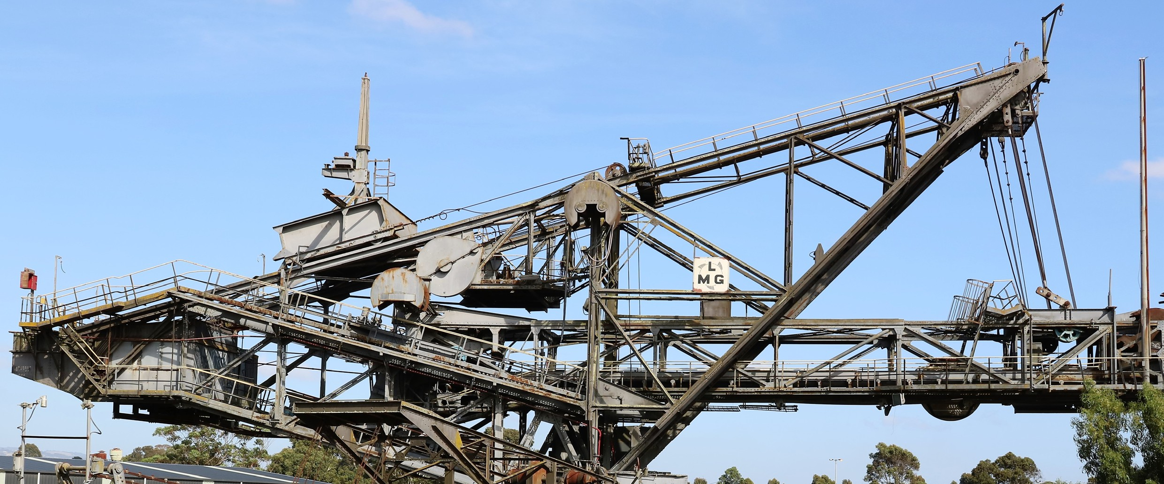

|  |  |  |
| --- | --- | --- |
| **Section** | **Source** | **Date** |
| **Transmission Infrastructure Projects** |  |  |
| All | [Integrated System Plan](https://aemo.com.au/energy-systems/major-publications/integrated-system-plan-isp/2024-integrated-system-plan-isp)[20]d, AEMO | 2024 |
| **Employment** |  |  |
| Average working age, median income, labour force participation | [Census](https://www.abs.gov.au/statistics/microdata-tablebuilder/tablebuilder), ABS | 2021 |
| Regional Labour Market Index | [Regional Labour Market Indicator, Jobs and Skills Australia](https://www.jobsandskills.gov.au/data/regional-labour-market-indicator) | December 2024 |
| Unemployment rate: |  |  |
| * Latrobe * Victoria | [Small Area Labour Markets](https://www.dewr.gov.au/employment-research/small-area-labour-markets), Jobs and Skills Australia [Labour Force, Australia](https://www.abs.gov.au/statistics/labour/employment-and-unemployment/labour-force-australia/dec-2024), ABS | December 2024  December 2024 |
| **Demographics** |  |  |
| All | [Census](https://www.abs.gov.au/statistics/microdata-tablebuilder/tablebuilder), ABS | 2021 |
| **Housing** |  |  |
| Homelessness, mortgage stress, rental stress | [Census](https://www.abs.gov.au/statistics/microdata-tablebuilder/tablebuilder), ABS | 2021 |
| Commonwealth Rental Assistance | [Benefit and Payment Recipient Demographics - quarterly](https://data.gov.au/data/dataset/dss-payment-demographic-data/resource/38a5c0c7-5246-428b-bc0c-3d1fe153ea78) [data](https://data.gov.au/data/dataset/dss-payment-demographic-data/resource/38a5c0c7-5246-428b-bc0c-3d1fe153ea78), DSS | December 2024 |
| **Maps** |  |  |
| All | Produced using data from [Australian Bureau of Agricultural](https://www.agriculture.gov.au/abares#%3A~%3Atext%3DWelcome%20to%20the%20Australian%20Bureau%2Cof%20Agriculture%2C%20Fisheries%20and%20Forestry) [and Resource Economics and Sciences (ABARES)](https://www.agriculture.gov.au/abares#%3A~%3Atext%3DWelcome%20to%20the%20Australian%20Bureau%2Cof%20Agriculture%2C%20Fisheries%20and%20Forestry), DAFF | December 2023 |

Note: All datasets maintained by third party providers listed above and date reflects most recent data available

1. a Access may be restricted on a secure network: https://aemo.com.au/energy-systems/electricity/national-electricity- market-nem/nem-forecasting-and-planning/forecasting-and-planning-data/generation-information
2. Values may not add to total due to rounding
3. b Access may be restricted on a secure network: https://aemo.com.au/energy-systems/electricity/national-electricity- market-nem/nem-forecasting-and-planning/forecasting-and-planning-data/generation-information
4. Values may not add to total due to rounding
5. Values may not add to total due to rounding
6. Data sourced using REMPLAN (incorporating ABS 2021 Census Place of Work Employment (Scaled); 2022 / 2023 National Input Output Tables; June 2024 Gross State Product figures)
7. Data by usual residence means only employees living in Latrobe Gippsland region would be captured (regardless of whether or not they actually work in Latrobe Gippsland).
8. Data by place of work means only employees working in Latrobe Gippsland region would be captured (regardless of whether or not they actually reside in Latrobe Gippsland).
9. Note, for purposes of calculating shares of workforce, total of 122,175 was used (total workforce minus those workers in ‘Industry of Employment’ categories listed as ‘inadequately described’ and ‘not stated’).
10. Note, for purposes of calculating shares of workforce, total of 108,702 was used (total workforce minus those workers in ‘Industry of Employment’ categories listed as ‘inadequately described’ and ‘not stated’).
11. Note, Regional Labour Market Index is calculated by SA4. Score shown reflects Latrobe-Gippsland SA4.
12. Excludes ‘not stated’ and categories are not cumulative
13. Share of population
14. Share of population
15. Share of households where repayments are >30% of household income
16. Share of households where rent payments are >30% of household income
17. a Access may be restricted on a secure network: https://www.aemo.com.au/energy-systems/electricity/national- electricity-market-nem/nem-forecasting-and-planning/forecasting-and-planning-data/generation-information
18. b Access may be restricted on a secure network: https://www.remplan.com.au
19. c Access may be restricted on a secure network: https://research.csiro.au/hyresource/projects/projects-spreadsheet/
20. d Access may be restricted on a secure network: https://aemo.com.au/energy-systems/major-publications/integrated- system-plan-isp/2024-integrated-system-plan-isp