Central Queensland

**Total Area**: 107,744 sq. km          **Population**: 221,445 **Working Zones**: Banana, Biloela, Central Highlands-East, Emerald & Central Highlands-West, Gladstone & surrounds**,** Rockhampton & surrounds, Yeppoon & surrounds (*maps at end*)

**Region Selection Rationale**

| **Exposure to decarbonisation** | **Potential to harness economic opportunities from decarbonisation** |
| --- | --- |
| * **Carbon intensity**: Large number of facilities (incl. 4 coal-fired power stations and 21 safeguards. As of 2023-24, safeguards in the region account for 54% of Qld’s safeguard scope 1 emissions); high carbon-intensive employment * **Urgency:** 2 coal-fired power stations projected to close by 2035. * **Adaptive capacity**: Moderate with pockets of lower adaptive capacity, particularly in areas with higher concentration of coal mining. * **Readiness**: no specific regional transition planning for Central Qld (outside of Gladstone) but some regional planning in areas such as Central Highlands. | * **Natural capital:** Considerable green industry potential – including green aluminium and alumina, strong renewable energy resources (solar & wind). * **Workforce compatibility**: High proportion of workers in Central Qld North and Gladstone in roles compatible with forecast clean energy occupations. Medium compatibility in Central Qld South. * **Enabling infrastructure:** High, including 5G presence, Gladstone airport and proposed future hydrogen port in region. Port of Gladstone has eight main wharf centres, comprising 20 wharves in total, handling export of over 30 different products. Curtis Island is home to the LNG export terminals, the only such facilities on Australia’s east coast. |

**Carbon-Intensive Industries**

**Coal Fired Power Stations (CFPS)[1]**

| **Name** | **Owner** | **Public closure date**  **(**[AEMO NEM Gen Apr 2025](https://aemo.com.au/energy-systems/electricity/national-electricity-market-nem/nem-forecasting-and-planning/forecasting-and-planning-data/generation-information)**)** | **Supplying Coal Mine** | **Scope 1 emission(tCO2-e) (23/24)** | **% of Scope 1 Qld emissions (23/24)** | **% of Scope 1 Aus emissions (23/24)** |
| --- | --- | --- | --- | --- | --- | --- |
| Stanwell | Stanwell (Qld gov.) | 2043 | Curragh | 7.0 m | 8% | 2% |
| Gladstone | Rio Tinto, NRG Energy & others | 2035 | Rolleston, Callide, & Ensham | 6.5 m | 7% | 2% |
| Callide B | CS Energy (Qld gov.) | 2031 | Callide | 4.0 m | 5% | 1% |
| Callide C | IG Power & CS Energy (Qld gov.) | Not provided | Callide | 0.7 m | 1% | 0.2% |
| Total: 4 |  |  | 4 | 18.1 m | 21% | 6%[2] |

**Metal Manufacturing / Refineries and Smelters**

| **Name** | **Owner** | **PPA expiry date** | **Power source** | **Scope 1 emissions (tCO2-e) (23/24)** | **% of Scope 1 Qld emissions (23/24)** | **% of Scope 1 Aus emissions (23/24)** |
| --- | --- | --- | --- | --- | --- | --- |
| Boyne aluminium smelter | Rio Tinto, Sumitomo, others | 2029 | Gladstone CFPS | 0.9 m | 1.0% | 0.3% |
| Yarwun alumina refinery | Rio Tinto | N/A | Gas-fired cogeneration plant, Gladstone CFPS | 2.1 m | 2.4% | 0.7% |
| Queensland alumina refinery | Rio Tinto, Rusal | N/A | Gladstone CFPS | 3.1 m | 3.5% | 1% |
| Total: 3 |  |  | 2 | 6.1 m | 7.0% | 2.0% |

**Coal mines**

| **Type** | **No.** |
| --- | --- |
| Safeguards | 14 |
| Non-safeguards | 2 |
| Total | 16 |

**Safeguard Facilities** *(Emit 100,000+ tonnes CO2 annually - power stations connected to grid are exempt)*

| **Type** | **No.** | **Total scope 1 emissions (tCO2-e) (23/24)** | **% of Qld scope 1 safeguard emissions (23/24)** | **% of Aus scope 1 safeguard emissions (23/24)** |
| --- | --- | --- | --- | --- |
| Manufacturing | 7 | 8.5 m | 23% | 7% |
| Coal mines[3] | 14[4] | 5.7 m | 15% | 4% |
| Oil & gas extraction | 4 | 5.8 m | 15% | 5% |
| Total safeguards | 25[5] | 20.0 m | 54% | 16% |

**Major Industries**

**Gross Regional Product (GRP):** $34.6 billion (7.2% of Qld’s Gross State Product)[6]

|  |  |  |
| --- | --- | --- |
| **Ranked Industries with most value** | **Value (m)** | **% of GRP** |
| Mining | $18,017 | 52.1% |
| Rental, Hiring & Real Estate Services | $2,459 | 7.1% |
| Construction | $1,949 | 5.6% |
| Health Care & Social Assistance | $1,593 | 4.6% |
| Manufacturing | $1,473 | 4.3% |

| **Ranked Employing Industries  (by usual residence[7])** | **No. of employees (% of workforce)** | **Ranked Employing Industries  (by place of work[8])** | **No. of employees (% of workforce)** |
| --- | --- | --- | --- |
| Total labour force living in region | 102,177[9] | Total labour force working in region | 100,852[10] |
| Health Care and Social Services | 13,144 (13%) | Health Care and Social Services | 12,930 (13%) |
| Retail & Wholesale Trade | 11,395 (12%) | Retail & Wholesale Trade | 11,533 (12%) |
| Education & Training | 9,344 (10%) | Educating & Training | 9,334 (10%) |
| Construction | 8,764 (9%) | Mining | 9,251 (10%) |
| Mining | 8,691 (9%) | Construction | 7,929 (8%) |

**Major Investments**

**Major clean energy and heavy industry projects (top 5 by value)**

| Project | Description | Category | Status[11] | Value |
| --- | --- | --- | --- | --- |
| H2-Hub(TM) Gladstone | An industrial-scale green hydrogen and ammonia production complex | Green hydrogen | Under development | $4,700 m |
| Brigalow Peaking Power Plant | The Brigalow Peaking Power Plant is proposed to feature up to 12 modular turbines, supplied by GE Verona, which are capable of using a blend of renewable hydrogen and natural gas. The power plant is forecast to be operational in 2027. | Green Hydrogen | Under development | $642 m |
| Aldoga Solar Farm | A flagship renewable energy project which will be directly connected to the electricity grid | Renewable energy | Under Construction | $550 m |
| Gladstone PEM50 Project | A new electrolysis plant in Gladstone to manufacture renewable hydrogen with production targeted for 2025 | Green hydrogen | Under Construction | $150 m |
| Green Methanol Feasibility Study | Cement Australia and Mitsubishi Gas Chemical Company (MGC) signed a Memorandum of Understanding in October 2022 to conduct a feasibility study on green methanol production. | Non-Green Hydrogen | Under Construction | $150 m |

**Transmission Infrastructure Projects**

**AEMO Final 2024 Integrated System Plan transmission infrastructure projects**

|  |  |  |  |  |
| --- | --- | --- | --- | --- |
| Name​ | Description​ | Status ​ (Draft 2024 ISP Status)​ | Timing ​ (Draft 2024 ISP Timing)​ | Costs​ |
| Gladstone Grid Reinforcement | Increase network capacity from Central Qld into the Gladstone area to support the area’s industry once Gladstone Power Station retires and add capacity between Northern and Southern Qld. | Actionable (unchanged) | Mar 2029 (Sep 2029) | $1,300 m (±50%). |
| Queensland SuperGrid South | Stage 2 of the SuperGrid, under the Qld Energy and Jobs Plan, to greatly increase the transfer limit between Central and Southern Qld and connect to the Borumba Pumped Hydro project. | Actionable (unchanged) | Sep 2031 (June 2031) | $3,300 m (±50%) |
| Queensland SuperGrid North | Add transfer capacity between Central and North Qld, and enable capacity in northern  Qld REZs. | Future (unchanged) | 2032-33 (unchanged) | $4,200 m (±50%) |

**Employment**

| **Indicator** (2021 Census unless otherwise stated) | **Central Queensland** | **Queensland** |
| --- | --- | --- |
| Average working age | 39 | 38 |
| Median income (annual gross, exc. super) | $33.8K - $41.6K | $33.8K - $41.6K |
| Participation in workforce | 62% | 62% |
| Female participation in workforce | 59% | 59% |
| Unemployment rate (Dec 2024) | 4.8% | 3.9% |
| Regional Labour Market Index (Dec 2024) | Average | N/A |

**Demographics**

| **Indicator** (2021 Census) | **Central Queensland** | **Queensland** |
| --- | --- | --- |
| Median age | 37 | 38 |
| First Nations (% of population) | 7% | 5% |
| Population growth (2016 – 2021) | 3% | 10% |
| Educational attainment (% of population aged 15 & above)* |  |  |
| * Below Y12 | 51% | 41% |
| * Y12 or equivalent | 49% | 59% |
| * Cert III & IV | 26% | 21% |
| * Bachelor and above | 14% | 24% |

* *Excludes ‘not stated’ and categories are not cumulative*

**Housing**

| **Indicator** (2021 Census unless otherwise stated) | **Central Queensland** | **Queensland** |
| --- | --- | --- |
| Homelessness[12] | 0.4% | 0.4% |
| Commonwealth Rent Assistance (Dec 2024)[13] | 6% | 6.6% |
| Mortgage stress[14] | 9% | 12% |
| Rental stress[15] | 24% | 32% |

**Map of Region – Power Stations and Mines**

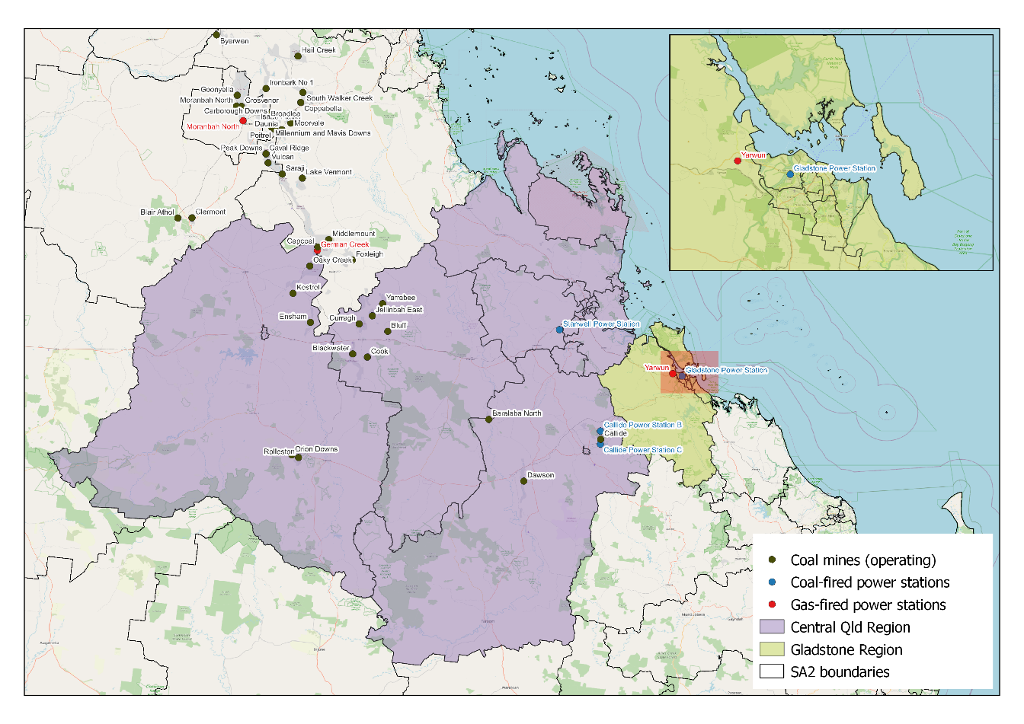

**Map of Region – Safeguards**

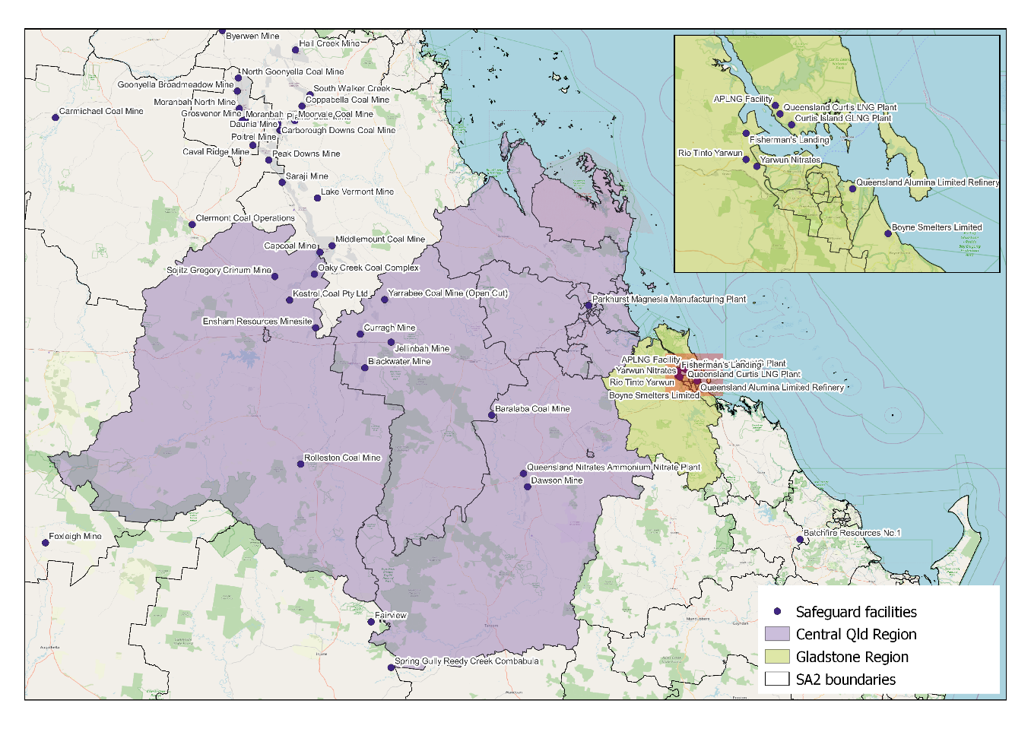

**Data Sources**

|  |  |  |
| --- | --- | --- |
| **Section** | **Source** | **Date** |
| Overview | | |
| Total Population | [Census](https://www.abs.gov.au/statistics/microdata-tablebuilder/tablebuilder), ABS | 2021 |
| Area | [Mesh Blocks - SA2 Allocation Files](https://www.abs.gov.au/statistics/standards/australian-statistical-geography-standard-asgs-edition-3/jul2021-jun2026/access-and-downloads/allocation-files), ABS | 2021 |
| Priority Region Selection Rationale | | |
| All | [Regional identification framework](https://www.netzero.gov.au/sites/default/files/documents/2025-03/NZEA_Regional_Framework%20%281%29.pdf) | February 2025 |
| Carbon Intensive Industries | | |
| Coal Fired Power Stations | [Greenhouse and energy information by designated generation facility](https://cer.gov.au/markets/reports-and-data/nger-reporting-data-and-registers/electricity-sector-emissions-and-generation-data-2023-24), CER (Gladstone & CQLD)  [Greenhouse and energy information - published data highlights](https://cer.gov.au/markets/reports-and-data/nger-reporting-data-and-registers/2023-24-published-data-highlights) (QLD) | 2023-24 |
| Metal Manufacturing / Smelters & Refineries | [Safeguard facilities data](https://cer.gov.au/markets/reports-and-data/safeguard-data/2023-24-baselines-and-emissions-data), CER | 2023-24 |
| Coal mines | [Safeguard facilities data](https://cer.gov.au/markets/reports-and-data/safeguard-data/2023-24-baselines-and-emissions-data), CER | 2023-24 |
| Safeguard facilities | [Safeguard facilities data](https://cer.gov.au/markets/reports-and-data/safeguard-data/2023-24-baselines-and-emissions-data), CER | 2023-24 |
| Major Investments | | |
| All | [Funded projects](https://arena.gov.au/projects/?project-value-start=0&project-value-end=200000000), ARENA  [HyResource](https://research.csiro.au/hyresource/projects/projects-spreadsheet/), CSIRO  [Resources and Energy Major Projects](https://www.industry.gov.au/publications/resources-and-energy-major-projects-2024), DISR | 2025  2025  2024 |
| Major Industries | | |
| Ranked Industries by value | [Growing the Gladstone Region](https://www.gladstone.qld.gov.au/downloads/file/3793/gladstone-region-eds-2021-2025-recommendations), Gladstone Regional Council  [Economic data](https://login.remplan.com.au/), REMPLAN | 2021  2025 |
| Ranked Employing Industries | [Census](https://www.abs.gov.au/statistics/microdata-tablebuilder/tablebuilder), ABS | 2021 |
| Transmission Infrastructure Projects | | |
| All | [Integrated System Plan](https://aemo.com.au/en/energy-systems/major-publications/integrated-system-plan-isp/2024-integrated-system-plan-isp), AEMO | June 2024 |
| Employment | | |
| Average working age, median income, labour force participation | [Census](https://www.abs.gov.au/statistics/microdata-tablebuilder/tablebuilder), ABS | 2021 |
| Regional Labour Market Index | [Regional Labour Market Indicator, Jobs Skills Australia](https://www.jobsandskills.gov.au/sites/default/files/2025-02/regional_labour_market_indicator_results_-_december_2024.pdf) (Central Qld SA4) | December 2024 |
| Unemployment rate:   * Gladstone & CQLD * Queensland | [Small Area Labour Markets](https://www.dewr.gov.au/employment-research/resources/salm-smoothed-sa2-datafiles-asgs-2021-december-quarter-2024), Jobs and Skills Australia  [Labour Force, Australia](https://www.abs.gov.au/statistics/labour/employment-and-unemployment/labour-force-australia/dec-2024), ABS | December 2024  December 2024 |
| Demographics | | |
| All | [Census](https://www.abs.gov.au/statistics/microdata-tablebuilder/tablebuilder), ABS | 2016 & 2021 |
| Housing | | |
| Homelessness, mortgage stress, rental stress | [Census](https://www.abs.gov.au/statistics/microdata-tablebuilder/tablebuilder), ABS | 2021 |
| Commonwealth Rental Assistance | [Benefit and Payment Recipient Demographics - quarterly data](https://data.gov.au/dataset/ds-dga-cff2ae8a-55e4-47db-a66d-e177fe0ac6a0/details), DSS | December 2024 |
| Maps | | |
| All | Produced using data from [Australian Bureau of Agricultural and Resource Economics and Sciences](https://www.agriculture.gov.au/abares#:~:text=Welcome%20to%20the%20Australian%20Bureau,of%20Agriculture%2C%20Fisheries%20and%20Forestry.) (ABARES), DAFF | December 2023 |

Note: All datasets maintained by third party providers listed above and date reflects most recent data available.

1. Power stations listed include only those connected to the grid.
2. Individual percentages may not add up to total due to rounding.
3. Not all coal mines qualify as a safeguard facility. The total number of coal mines in Central QLD is 16 facilities.
4. Ensham’s underground coal mine is listed as separate coal mine, meaning Ensham is listed twice.
5. Per above, for purposes of calculating total safeguard number for the region, total is 22 (treating Ensham’s two mines as one mine).
6. Data sourced using REMPLAN (incorporating ABS 2021 Census Place of Work Employment (Scaled); 2022 / 2023 National Input Output Tables; June 2024 Gross State Product figures)
7. Data by usual residence means only employees living in Gladstone & Central QLD region would be captured (regardless of whether or not they actually work in Gladstone & Central QLD).
8. Data by place of work means only employees working in Gladstone & Central QLD region would be captured (regardless of whether or not they actually reside in Gladstone & Central QLD).
9. Note, for purposes of calculating shares of workforce, total of 98,203 was used (total workforce minus those workers in ‘Industry of Employment’ categories listed as ‘inadequately described’ and ‘not stated’).
10. Note, for purposes of calculating shares of workforce, total of 96,943 was used (total workforce minus those workers in ‘Industry of Employment’ categories listed as ‘inadequately described’ and ‘not stated’).
11. Excluding projects that are archived, completed and paused
12. Share of population
13. Share of population
14. Share of households where repayments are >30% of household income
15. Share of households where rent payments are >30% of household income